Title: Llanfihangel ar Arth – Ensuring the survival of a rural Welsh-speaking community
Synopsis/Overview:
Closure of the local Welsh language primary school threatened village life until local people took over the school buildings and developed a Community Centre.

When: 2003 until today | Where: Llanfihangel ar Arth, Carmarthenshire, Wales
Background:
The majority Welsh-speaking, village of Llanfihangel ar Arth (population c.3000) in Carmarthenshire used to have a Welsh language primary school, which had always been at the heart of the community. Because of falling numbers, and despite local protests, the county council closed the school in 2003, and within a year the local post office and shop had also disappeared. The use of the Welsh language locally was particularly threatened as half the village children now went to English-language schools in the neighbouring county of Ceredigion. Fearing for the future of the village, some local residents decided that the hall of the now redundant school building should be developed as a community centre, initially against the wishes of the local authority.

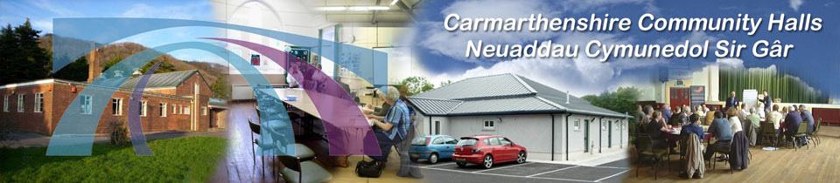
The Story:
At an initial meeting, local activists formed a School Hall Society and began to develop plans to renovate the School Hall into a lively centre for the local community with emphasis on activities for young people. At first, the local council did not support the Society’s plans, but they moved into the School Hall anyway and began to develop a programme of local activities, including a Welsh speaking youth club (Urdd), a homework club, and IT club and a Welsh Learners’ Club. Eventually the local authority fell into line with a grant to help develop the community centre.

What changes did they want to make?
They wanted to ensure that their village survived as a thriving community, with a particular emphasis on activities for children and young people and on fostering Welsh as the majority language of the village.

Who did they try to influence?
The local authority and – ultimately – the Welsh Government.
What failed, and why?
The village community didn’t succeed in keeping their local primary school open, but they were successful in developing the school hall as a community hub and even in attracting funds to develop it.

What succeeded, and why?
There is now a thriving community hub in the village, with an emphasis on providing support for children, and the Welsh language, locally. People involved in the School Hall Project now give advice on campaigning to other local communities, including on how to oppose the closure of local schools.

Follow-up Activities:
1. Consider the story of Llanfihangel ar Arth. What strategies did the villagers use and what qualities and skills did they demonstrate?

2. In groups, consider your school or local community. Is there a building or an area which needs developing, and how would it serve the needs of your school / community? Plan a creative project and map it out. What steps would you need to take? Who would you need to consult and involve? Who could support you? Who would benefit and what might the obstacles be?

Now pass your plan to the group on your right. Spend some time looking at one another’s plans, and play the role of a ‘critical friend’. Does this project meet the school’s / community’s needs? Is it realistic and doable?

Come back together and present one another’s plans? Which one(s) do you want to take forward? Could any of your ideas be combined?

Further Info/Links:

http://www.carmarthenshirehalls.org.uk/hall.php?hall_id=39
Both include an apparently non-copyright photo.

http://www.dailypost.co.uk/news/north-wales-news/well-fight-protect-village-way-2903173
Halfway down this article, which is more generally about the closure of rural schools, is a very vivid description of the impact on Llanfihangel ar Arth and especially on the use of Welsh language locally, when its school closed.

https://www.facebook.com/pg/llanfihangelararth/about/?ref=page_internal

What can you do?
Take the idea or ideas from Activity 2 above and develop it as a class / school project.
Once the project is completed, you could invite local councillors / Senedd Members / MPs to celebrate it with you and write an article for your local newspaper or do an interview for local media.

