Title: Women for Life on Earth walk from Cardiff to Greenham Common - Greenham Common Peace Camp.

Synopsis/Overview:
Ann Pettit who lived in West Wales wanted to do something to highlight the plan by America to site cruise missiles at Greenham Common American airbase.
Opposition to nuclear weapons and their production was growing and there was the added threat that Britain would have no control over what happened at the airbase.
Ann got together with Carmen (Cutler) to plan the walk, which was initially called ‘Women for Life on Earth’. The Campaign for Nuclear Disarmament (CND) gave a grant to Ann to support the initiative.

When: 1981 | Where: Cardiff to Greenham, Berkshire
Background:
Proliferation of nuclear weapons and the wish to do something about it was what drove the action. Ann wanted the walk to be women-led as she and the four women who eventually planned the walk feared for their children's future. Men go to war; women now must work for peace. There was also major concern about American bases on British soil and the secrecy surrounding what was happening in them.

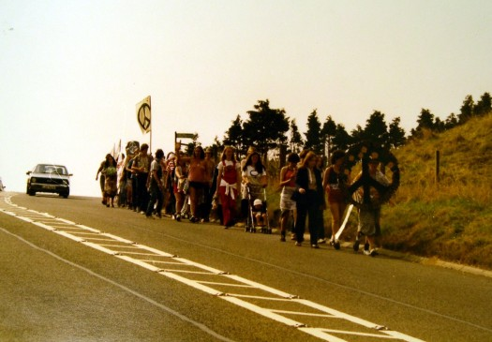
The Story:
The walk consisted of 40 women (including 2 15year olds) 4 men and 3 babies of between 13 and 18 months, plus many supporters who walked various stretches of the route. It also involved many local peace/CND groups as well as numerous Christian church groups of all denominations including Quakers, Catholic, Methodist. Beds in people's homes were offered as well as floor space on church hall floors. The night before the walk was spent at the Quaker Meeting House, Cardiff and the second at Eton Rd Community Centre Newport where there is a plaque.

The aim of the action and the content changed and so it could actually be seen as 2 actions, the walk and the peace camp. The initial action was designed to get publicity for the nuclear threat and America’s involvement. This aim was not successful as the women got no national news coverage, although there was local publicity and also good publicity in Wales for the start of the walk with radio, TV and press attention. Peacemakers in Wales have always been proud that the Greenham Common campaign started there.

Given the lack of national publicity, a meeting was held toward the end of the walk and a plan was hatched that 4 women would chain themselves to the base's perimeter fence by the main gate and demand to meet with the Commander of the base. When the women arrived at the head of a 2,000 strong noisy, singing and dancing march on September 5th 1981 the 4 women had already chained themselves up and proceeded to swop with others for comfort breaks. Carmen handed in a letter to the Commander asking for a meeting. The letter stated|: ‘We fear for the future of all our children and for the future of the living world which is the basis of all life’.

It was very hot weather so it wasn't difficult for many of the women and children to just stay - the 2 15 year olds Hannah and Lucy slept under one of the banners the first night. Some of the older women stayed along with 2 of the men and the Peace camp was born. In October many of the original women and the 3 babies walked from Greenham to London and Ann spoke at the rally at the end of a massive CND demonstration in Hyde Park.
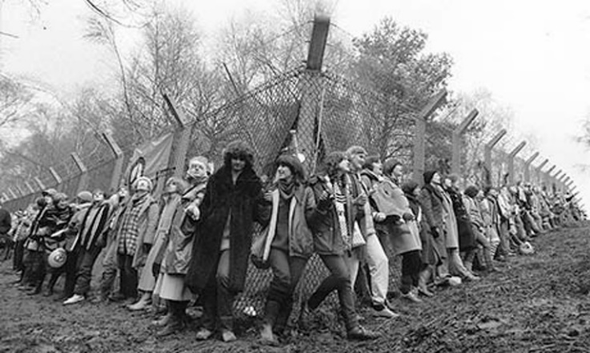
The camp gained publicity and became women only in February 1982. Women arrived from all over Britain and beyond to support the peace camp, and camps gradually appeared at some of the other gates dotted around the base. Local people were divided, but many supported the camp with food and bathing facilities.
In December 1982 30,000 women surrounded the base and this marked a very important date in the camp's life. There were many mass actions both legal and illegal and many evictions and court cases over the years. Often Groups of women would cut the fence and get into the base. On one occasion a picnic was held on top of one of the bunkers.
The peace camp’s protests continued after the arrival of the first Cruise missiles in November 1984. Roughly monthly, exercises would be held where the missiles would be driven out of Greenham Common at night to “melt into the countryside”. Each time this happened, peace campaigners would follow the missiles, often stopping the convoy, disproving the idea that the missiles could “melt into the countryside”.

Despite the signing of the Intermediate-range Nuclear Forces Treaty in 1987, when Russia and America agreed to destroy the Cruise missiles (and their Russian equivalent), the peace camp continued to be a centre of protests against nuclear weapons. The last Cruise missiles left Greenham Common in 1991.

The peace camp continued until the airbase was dismantled, and the land returned to common land, in 2000.

What changes did they want to make?
The women wanted to raise public awareness of the threat of nuclear weapons to humanity and their proliferation. They also wanted to highlight the added worry of the lack of British control over the missiles housed at the Greenham Common base. They wanted the weapons to be removed.

Who did they try to influence?
Initially they tried to influence the Base Commander by requesting a meeting to discuss their concerns. They also wanted to influence public opinion by raising awareness of the threat of nuclear weapons and the nuclear arms race. They wanted to put pressure on the British Government to remove nuclear weapons from British soil and to get rid of their nuclear weapons - also to increase support for nuclear disarmament nationally and internationally.

What failed, and why?
The protest which started with a march from Cardiff to Greenham was long and hard. The Women’s Camp remained for 19 years. (It was eventually disbanded in 2000). Living conditions were primitive and living outside in all kinds of weather was testing, with no electricity, telephone, running water etc., and with frequent evictions and vigilante attacks. It was a case of giving up comfort for commitment.

Although the nuclear missiles were removed from the site in 1991 and returned to the US, Britain still retains its nuclear ‘deterrent’. Eight countries in the world are known to have nuclear weapons, with the US and Russia having huge stock-piles.

What succeeded, and why?
Massive publicity for the case against nuclear weapons and empowerment for women.
The missiles arrived at the base in 1984 amid much publicity rather than the secrecy the authorities wanted.

The Cruise Missiles were removed from the Greenham Common base – an achievement that was in no small part due to the conduct and integrity of the protest mounted by the Women’s Peace Camp. Under the Intermediate Nuclear Forces (INF) Treaty, the missiles were flown back to the USA along with the US Air Force personnel in 91/92.

Eventually the base was returned to the community and the common is now open to the public. There is a peace garden with a memorial to Helen Thomas, a 23-year-old Welsh woman killed there. She was crossing the road to post a letter when a police van was deliberately driven close to her to scare her. She sustained massive head injuries. There is also a sculpture depicting the camp fire which burned for 19 years and which women from all the world sat around.

Follow-up Activities:
- Find out more about the ‘Women for Life on Earth’ march and the Greenham Common Peace Camp, using the sources below.

- Non-violent methods:
Women who took part in the Greenham Common Peace Camp committed to peaceful methods of protest and were willing to suffer personal consequences as a result, including arrest. Techniques used included:
- ‘Locking on’ – linking arms and forming a human chain so that it was difficult to arrest one individual;
- Singing;
- Resisting arrest non-violently;
- Chaining themselves to the railings;
- Cutting the wire and entering the base;
- Using visual symbols such as the spider’s web, or posting pictures of children on the fence.

What do you think of these techniques? What effect do you think they had on the guards / staff at the base; the police / the general public?

Act out a scene where some of you are Greenham Women and some of you are base staff or police officers. What do you do? What do you say? How are you feeling?

- Hold a debate:
Use the links below and do some research online concerning the pros and cons of nuclear weapons, then hold a debate in your class – for instance: ‘Does the UK need a nuclear deterrent?’ or ‘Should nuclear weapons be abolished?’
Further Info/Links:
From Cardiff to Greenham Common: Women for Life on Earth – Glamorgan Archives: http://bitly.ws/pnPk

Greenham Common Peace Camp 35 years on (The Independent): https://www.independent.co.uk/news/uk/home-news/greenham-common-women-peace-camp-35-years-on-nuclear-weapons-feminism-a7040011.html

Video made by pupils of Ysgol Gyfun Cymer Rhondda about the Greenham Common Women: https://www.youtube.com/watch?v=gHiuE3VoeZM

"Other Girls Like Me", Stephanie Davies: https://www.stephanie-davies.com/other-girls-like-me

CND Cymru campaigns side by side with other movements in Wales and worldwide to rid Britain and the world of all weapons of mass destruction.

Greenham Common Everywhere has a Greenham and activism study pack.

CND Peace Education’s free Educational Resources: https://cnduk.org/education/free-teaching-resources/ The resource ‘Critical Mass’ has a Greenham Common activity using original source material for English and drama.

The cost of nuclear weapons:
Global Campaign on Military spending: https://demilitarize.org.uk/uk-nuclear-weapons-spending-2020/
CND: http://bitly.ws/pnTm
BASIC (Independent Think-tank): https://basicint.org/report-how-much-does-the-uk-spend-on-nuclear-weapons/

The International Campaign to Abolish Nuclear Weapons (ICAN) is a coalition of non-governmental organizations in more than one hundred countries promoting adherence to and implementation of the United Nations nuclear weapon ban treaty. This landmark global agreement was adopted in New York on 7 July 2017.
The Treaty on the Prohibition of Nuclear Weapons entered into force on 22 January 2021. 59 countries from all around the globe have now ratified this treaty. The problem is that this does not include those countries who possess nuclear weapons, including the UK.
What can you do?
- Invite someone into school from your local CND group and listen to what they have to say.
- The First Minister of Wales, Mark Drakeford, welcomed the ratification of the UN Treaty on the Prohibition of Nuclear Weapons in January 2021 (See: https://www.labourcnd.org.uk/tag/mark-drakeford/)
Invite members of the different political parties in Wales into school to tell you what their stance is on nuclear weapons, and be prepared to ask them questions.
- Write to your local MP / the Prime Minister to ask them to ensure that the UK ratifies the UN Treaty on the Prohibition of Nuclear Weapons.

