Title: Bridgend Nuclear Bunker – a Test Case for a Nuclear-free Wales
Synopsis/Overview:
In January – March 1982 members of the Campaign for Nuclear Disarmament (CND) set up a peace camp on Waterton Industrial Estate in Bridgend to protest against the secret building of a nuclear bunker to house Mid Glamorgan’s leaders in the event of a nuclear war. This was to cost around £400,000 and was contrary to the County’s official ‘nuclear free’ stance at the time. A well organised campaign involving peace groups, trade unions, churches and the media and then direct action at the site cause the Council to reverse its decision and abandon the bunker project altogether.

When: 1981 | Where: Waterton Industrial Estate, Bridgend
Background:
The 1970s saw a new period of development of the Cold War between East and West. The Soviet Union began deploying intermediate-range SS-20 nuclear missiles and NATO announced its decision to locate cruise and Pershing II land-based nuclear missiles in Western Europe by 1983. In the UK, RAF Base in Greenham Common, Berkshire, was selected as one of two British bases for US nuclear missiles. In the Spring of 1981 local authorities in Wales received Home Office Circular ES/1/81 urging them to "direct their
efforts" to the modernisation of plans for Wartime headquarters and shelter
accommodation for officials which should be "capable of implementation
within 48 hours" of the threat of nuclear attack.

There was a huge upsurge of concern and activity about this escalation of military activity from local branches of the Campaign for Nuclear Disarmament (CND) and other peace groups across Wales and pressure was put on the then 8 Welsh counties to support a resolution to become ‘nuclear free’.
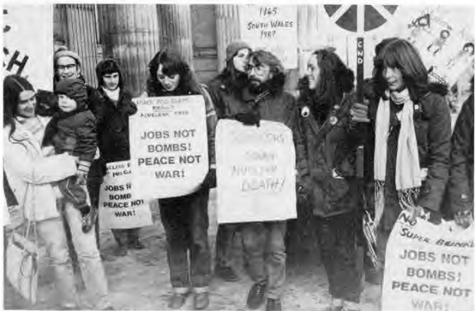
By December, six of the eight Welsh counties had done this. The two outstanding authorities were Mid Glamorgan and Clwyd. At their meeting in December 1981, Mid Glamorgan Councillors considered a resolution for the county to become nuclear free. However, at the same time, they also considered (and approved) a proposal for a large contract for what was described as a ‘Civil Emergency Centre’ – a £389,000 ‘super bunker’.

CND members had done their research about this centre and knew that it was to become, in the event of a nuclear crisis, a County Wartime Headquarters for council officials, working closely with the UK Government's own Sub-Regional Headquarters. Specifications included a decontamination room, blast walls, water tanks and recycling equipment and provision of doorways "to face away from greatest blast sources". This wartime shelter accommodation was also to include separate male and female toilets, dormitory accommodation and rest room provision where games could be played whilst ordinary citizens suffered the ultimate catastrophe above. Another factor to bear in mind was that this was a period of serious unemployment, when nearly £400,000 would have gone a long way to improve local services.

The Waterton case was therefore more than a local incident. In the words of Tony Simpson, who has documented the Bunker Campaign: ‘It signalled
a direct challenge to the wartime machinery of local councils and the Government's nuclear war plans in Wales. The siege of the Waterton bunker ultimately
became a test of local democracy and the strength and willpower of the campaign for a nuclear-free Wales.'

The Story:
Things came to a head in early January 1982. CND groups learned that the bunker contract would probably be approved by a special meeting of Mid Glamorgan’s Public
Protection Committee and that work may begin within a fortnight. An urgent letter was sent to the council, stating that the bunker project was "a complete contradiction of the nuclear free zone and also of Labour Party Policy", and giving notice that they would demonstrate directly against the contract. In the meantime, all constitutional methods would be used to stop the bunker, including approaches to Mid Glamorgan Council Members, politicians, and trade unions. Support for Mid Glamorgan CND also came from peace groups in South and West Glamorgan, Gwent and Dyfed.

When these methods brought no results, and with the belief that work would start at the site imminently, a peace camp was set up at the site on the week-end of 23rd – 24th January, 1982. 30 protestors blocked the entrance to the nuclear bunker, set up a caravan and declared their intention to stay there until work on the bunker had stopped. The contractors, the council and the police were taken by surprise.
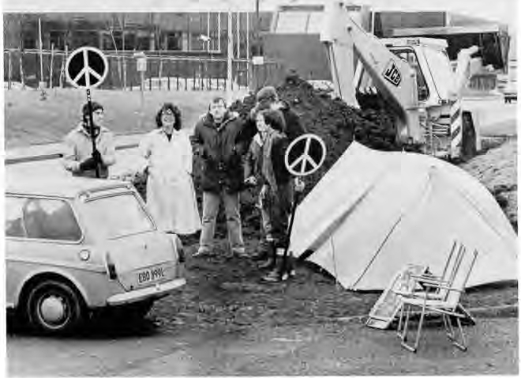
Mid Glamorgan CND Committee realised that – although the peace camp was important in holding up work – it needed to be backed up by other levels of action. A campaign was launched to "Keep Mid Glamorgan Nuclear Free", involving the publication of 30,000 leaflets, posters and badges. A series of weekly public rallies on the site was planned for people to see the work on the bunker and to mobilise action and publicity for the demands of the nuclear free campaign. Letters were sent to Trade Unions informing them of the action and inviting support - also to every factory and workplace on the surrounding industrial estate. A newsletter was produced for distribution to supporters and those attending the public meetings, and individual groups began distributing leaflets in the town centre.

The weekly meetings were successful in raising public awareness about what was really going on at the site. At the end of the first week, about 250 people gathered at the site, and quotes gathered at the meeting conveyed public opinion on the matter. Gareth Jones, a young father from Bridgend said: "I'm here because I'm concerned for my child's future and the future of every child. It's wrong that this money is being spent for such purposes when our schools and hospitals are being neglected", and Stella Jones from Cardiff said: "We cannot as ordinary democratic people stand by and see our money spent on a few people locked in preparing to run the country with guns. Democracy will go clear down the drain in favour of a military government….”

By 1st February (the 8th day of the protest), a breakthrough was made in that a group of elected Mid Glamorgan councillors agreed to meet with the protestors. Some councillors and politicians, including Bridgend’s MP, Ray Powell, expressed deep concern about what was happening at the site. A more formal meeting was agreed to discuss the issue at County Hall on 18th February. Prior to that meeting the CND Campaign Committee sent every elected member an ‘Information Pack’, including a summary of confidential council documents relating to the building of the nuclear bunker.

At the meeting on 18th February, a turning point appeared to have been reached. County Councillor Phillip Squire made a ‘statement of intent’ saying that the Council “would withdraw from any involvement relating to a war emergency scheme and declare the centre at the Waterton Industrial Estate at Bridgend to be a county civil emergency centre”. Another hopeful note was struck when, on 23rd February, Clwyd County Council declared itself a nuclear-free zone – the last of the Welsh local authorities to do so.

Despite these positive signs, work at the side continued and even increased in pace, with no apparent changes in the specification from a nuclear bunker to a civil emergency centre. On 1st March massive shuttering was put into place, and through communication with the workforce, peace camp members learned that construction of the outer blast walls would probably begin in the week beginning March 8, when large amounts of ready mixed concrete were expected to arrive on the site.

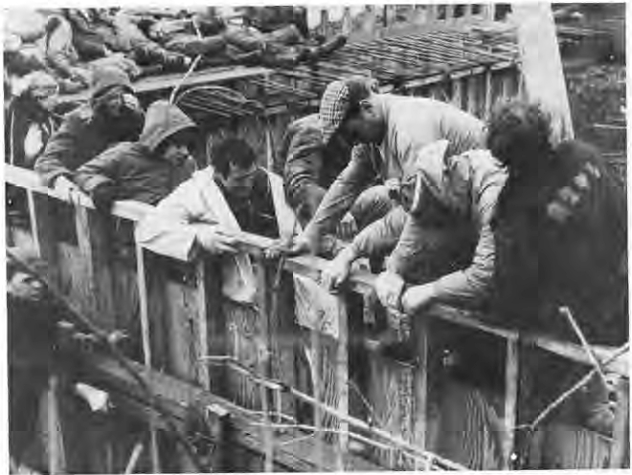
Having exhausted all other possibilities, the peace camp members felt that had no other choice to stop the construction of the bunker than to take direct action. The first tactic was to fill the cavity between the shuttering that was to be filled with concrete with debris – assorted items of clothing, mattresses and cushions, shoes, magazines and flowers. Then, whilst the workers were occupied with fishing this out of the space, a number of protestors climbed up onto the shuttering, then lay down on it – to form a physical barrier. At 12.30 pouring of concrete commenced, but work was obstructed by the human barrier, and progress was slow. Elsewhere on the site, small groups of supporters attempted to
prevent the arrival of cement mixers by talking to drivers and then standing in front of the vehicles. The direct action continued from 9 in the morning until 6 in the evening and attracted considerable media attention. One of the protestors described how they felt: “We stayed until we began to feel ill through exposure, as our clothes were soaking wet and heavy, clinging to our bodies. Mary's hand was also injured, and it was raining…. I told the TV that the Home Office must want the bunker very badly if they were prepared to allow such terrible risks in full view of the press and public.”

On Wednesday 10th March – 48 hours after the obstruction of the work, Mid Glamorgan County Council called an emergency session of the full council. Individual councillors were again lobbied by CND members, and an exhibition was set up in County Hall, including photographs of the site and of concrete being poured over protestors. In a massive swing of opinion, councillors voted 63 to 4 against the building of the bunker. CND’s case had won the day.

In a nice touch, when the peace camp lobbiers returned from County Hall, they found that the bunker had been "magically" converted into a Welsh cottage with quaint windows containing lace curtains, black cats and potted plants. The foreman of the works said to them: "I never thought you'd do it……but it shows what can be done when people stick together".

Following this victory, the peace camp was disbanded and Mid Glamorgan County Council abandoned the whole project. Six weeks later, the demolition gang were brought in and the Welsh bunker was reduced to a pile of rubble.

What changes did they want to make?
Mid Glamorgan CND committee identified four related aims for the Bridgend Bunker campaign and action:
- To get the work on the bunker stopped, which was contrary to the county’s supposed policy to become nuclear free;
- To expose the realities of civil defence plans in the county;
- To strengthen the council's nuclear free policy, by ensuring that intention was matched by reality; and
- To build a stronger peace movement in Mid Glamorgan.

Who did they try to influence?
CND’s main aim was to influence Mid Glamorgan Local Authority to abandon the bunker project and act in accordance with their commitment to be a nuclear-free county. This meant lobbying individual councillors, some of whom didn’t realise the extent of what was being proposed by the Council. A wider aim was to influence public opinion by exposing the real nature of the proposed bunker and encourage people to join the peace movement. Partnerships were made with trade unions and religious groups, amongst others, and full use was made of media contacts.

What failed, and why?
Tony Simpson, who wrote an account of the campaign, describes what he felt to be weaknesses in the campaign, largely due to a lack of resources and experience. More could have been done at the site, he writes, to inform and mobilise people and to provide a more positive experience for pickets and supporters.

Despite these reservations, the campaign was a huge success and fulfilled its four key aims.

What succeeded, and why?
Several factors contributed to the success of the campaign. Some of these are listed below:
- The committee, which was really a coming together of a number of local CND committees, was well organised and coordinated.
- They had done their research, and used this to good effect, including in communication with the media and also in lobbying councillors, politicians, trade unions and the general public.
- They used a range of methods to raise public opinion, including press releases, the use of leaflets and posters and public meetings.
- Partnerships were formed with several organisations, including trade unions and churches.
- At every stage, the CND Committee showed they were committed to democratic means first, contacting Council members and asking for meetings. Direct action was only used when all other avenues had been closed off, and it was always non-violent.
- When it came to the crunch, the CND peace camp protesters showed that they were willing to take personal responsibility and act with integrity for what they believed to be right. This was incredibly powerful.

At a meeting soon after the peace camp Jean Bryant, vice chairperson of Rhondda CND said, "We found it was not up to others, it was up to us. It was a victory over ourselves and our doubts that nothing could be done. We challenged authority and we won. We blew our trumpet and the walls came tumbling down. Now we must build for the future"

Follow-up Activities:
- Creative writing:
10 yr. old Anna Benson Thomas (Penybont Primary School) wrote the following poem, which she read to the peace camp at Waterton on 14th February, 1982:

Today I can see the grass, the sky, the trees and everything there is to see. I wonder what it's like in Heaven, because that's where we'll all end up if they press the button. I don't want to die, but what can I do about it? It's just a question of now you see us now you don't. It's like putting your life in someone else's hands. No one ever looks after your possessions as well as you do.

Won't someone tell me why people will kill themselves. Why fool ourselves that we can hide in some tin hut until it's all over, then come out into a world where everything is as it was. The world won't be the same! There will be dead bodies everywhere. I will be dead. They will begin a war, and end the world."

How do you feel about war/ nuclear weapons? Write a poem to express your feelings, and share with the rest of the class.

- Drama: Imagine …….
Imagine you are a member of the peace camp…..
- Describe how you felt and what you did on the first day of the protest (24th January)
- As the protest went on, what was it like? (Remember it was February. Were you cold? hungry? Did you miss not having a proper bath or shower?)
- Imagine conversations you had with the contracted workers, members of the public, the police…
- What did you feel like on 8th March, when you climbed onto the shuttering, then when concrete was poured over you?
- Describe your feelings on 10th March when you learned that the Council had changed its mind….

- Now imagine you are a member of the police or one of the construction workers who was supposed to pour the concrete. How do you feel towards the protestors? Imagine conversations between yourself and members of the peace group….

- Methods:
Look at the case study again. What methods did the CND Committee and the peace camp use? What do you think was most successful, and why?
If the campaign had taken place today, what other methods might they have used (e.g. social media)

- Debate:
Look at the WCIA resource ‘Critical Thinking and Debate Training’
Now organise a class debate.

Some suggested topics:
- Nuclear weapons are an effective deterrent / Nuclear weapons should be banned completely
- Trespassing on property or damaging property as part of a protest is never ok.

Further Info/Links:
Materials about the Bridgend Bunker Campaign on People’s Collection Wales: https://www.peoplescollection.wales/collections/1399456

See in particular Tony Simpson’s leaflet: ‘No Bunkers Here’: https://www.peoplescollection.wales/items/1398981

Wales online article: https://www.walesonline.co.uk/lifestyle/nostalgia/gallery/story-mothballed-fall-out-shelter-23346090

‘Towards a Nuclear-free Wales’ – Bethan Sian Jones, Peace News: https://peacenews.info/node/10051/towards-nuclear-free-wales

CND Cymru www.cndcymru.org

CND – ‘40 yr. anniversary of a Nuclear-free Wales’ : https://nation.cymru/news/exhibition-to-mark-40-years-since-the-nuclear-free-wales-declaration/

Critical thinking and debate training: https://www.wcia.org.uk/wp-content/uploads/2021/10/Critical-thinking-and-debate.pdf

Treaty on the Prohibition of Nuclear Weapons: https://bit.ly/3itkfEY

ICAN – International Campaign to Abolish Nuclear Weapons: https://www.icanw.org/

What can you do?
- The Treaty on the Prohibition of Nuclear Weapons entered into force on 22 January 2021. However, a number of governments (in particular those with nuclear weapons!) have not been signed the treaty. This includes the UK government.

The Welsh First Minister, Mark Drakeford, has welcomed the UN Nuclear Ban Treaty and local authorities in Wales are also beginning to show their support. So far, Bangor city council, Nefyn town council, Gwynedd county council and Merthyr Tydfil county borough council have adopted resolutions supporting the treaty.

Write a letter to your local authority, asking them to support the UN Treaty on the Prohibition of Nuclear Weapons. You can contact your local press, let them know you are doing this, and publicise the response you receive from your council.

- If you want to know more about how people are trying to ban nuclear weapons, contact CND Cymru www.cndcymru.org.

