Title: The Anti-Apartheid Movement in Wales – a successful pressure-group Campaign
Synopsis/Overview:
The Wales Anti-Apartheid Movement (WAAM) worked for the isolation of the Apartheid regime in South Africa on all fronts - political, economic , cultural and sporting with remarkable support from the people of Wales . In 1989 the Wales Rugby Union broke links with Apartheid Rugby. The movement was active in most parts of Wales and was renowned for its campaigns for example on the boycott of South African goods and the picketing of supermarkets. When Nelson Mandela received the “Freedom of The City of Cardiff” in 1998 he thanked the people of Wales for their actions of Solidarity with the oppressed people of South Africa.

When: 1981 - 1994 | Where: Across Wales
Background:
Apartheid was a system of legislation that upheld segregationist policies against non-white citizens of South Africa. After the National Party gained power in South Africa in 1948, its all-white government immediately began enforcing existing policies of racial segregation. Under apartheid, non-white South Africans (a majority of the population) were forced to live in separate areas from whites and use separate public facilities. Contact between the two groups were limited. Despite strong and consistent opposition to apartheid within and outside of South Africa, its laws remained in force for almost 50 years.

There was a strong anti-apartheid movement in Wales. Its efforts were coordinated between 1981 and 1994 (after apartheid was abolished in South Africa) through the Wales Anti-Apartheid Movement (WAAM).

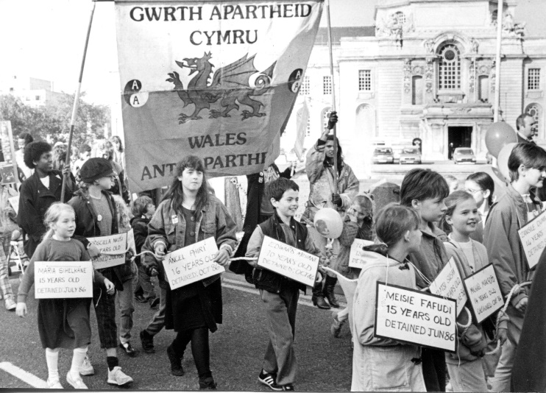
The Story:
Local groups and branches supporting the Anti-Apartheid Movement had been active in Wales prior to the setting up of WAAM, based in cities such as Cardiff, Newport and Swansea, but they realised that they could achieve a greater level of support if they operated as a national movement in Wales, with a clear Welsh identity.

WAAM worked for the isolation of the Apartheid regime in South Africa on all fronts. Its campaigns covered sports, cultural and consumer boycotts, and campaigns against investment in South Africa by British and international companies and banks – also against nuclear and military collaboration.

WAAM was supported by a network of local anti-apartheid groups, individual members, student groups and affiliated organisations such as trade unions and constituency political parties. Many people got involved in fundraising and demonstrations, as well as refusing to buy South African goods and picketing supermarkets. People also supported international campaigns for the release of Nelson Mandela and other political prisoners and detainees who had been imprisoned by the Apartheid regime. In 1989 the Wales Rugby Union broke links with Apartheid Rugby. When Nelson Mandela received the “Freedom of The City of Cardiff” in 1998 he thanked the people of Wales for their actions of Solidarity with the oppressed people of South Africa.

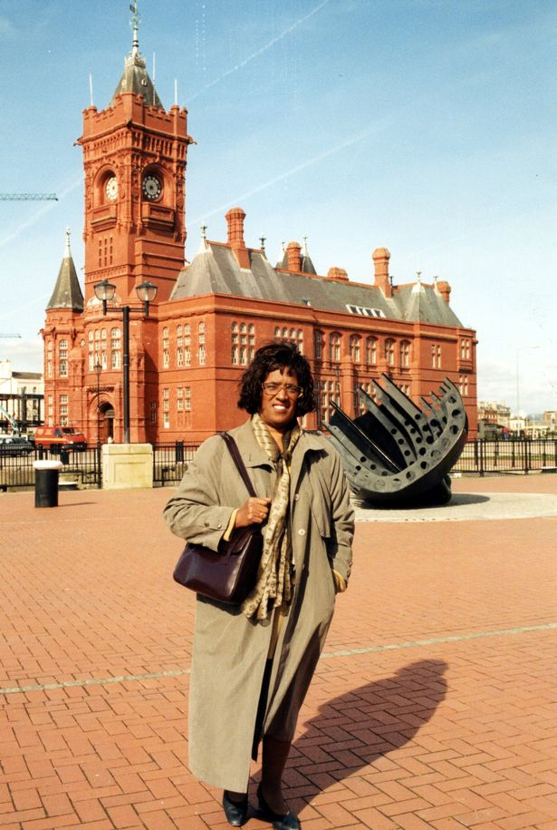
So this was a national campaign. At the same time, it was supported by some remarkable individuals. WAAM’s Secretary Hanef Bhamjee, who fled South Africa in 1965 at the age of 18, more or less led the campaign from his home for several years, supported by volunteers. Another key figure was Bert Pearce, Secretary of the Communist Party in Wales who, in his quiet unassuming way created key contacts for WAAM across all levels of society – including churches, trade unions and local councils. When Nelson Mandela was given freedom of the city in Cardiff he mentioned Bert in person as a key activist who had helped to secure the success of the anti-apartheid movement. A third figure was the politician, Peter Hain, whose White South African parents were forced to flee the country in the 1960s because of their opposition to the regime.

The Anti-apartheid regime came to an end in the early 1990s, Nelson Mandela was released and a democratic South African government was formed in 1994, with Nelson Mandela as the first Black President of South Africa.

Meanwhile, as illustrated by the life and career of Betty Campbell, Wales’ first Black (Woman) head teacher and champion of multiculturalism, work to establish social, cultural and political equality is an ongoing task. This is why movements such as ‘Black Lives Matter’ are so important.

What changes did they want to make?
WAAM, as part of a world-wide anti-apartheid movement, wanted to put pressure on public opinion and ultimately on the South African government to abolish the anti-apartheid system and hold free and fair elections in South Africa. They also wanted the release of political prisoners such as Nelson Mandela.

Who did they try to influence?
Sporting and cultural organisations, commercial institutions – also politicians. Ultimately, they wanted to influence public opinion and many people joined in demonstrations and boycotted South African goods in shops and supermarkets.

What failed, and why?
The campaign was in the end successful, but it took a long time. Nelson Mandela spent 27 years of his life in prison and many people in South Africa suffered because of the apartheid regime. Leaders of the anti-apartheid movement in the UK and around the world were targeted by South African agents: former MP and Cabinet Member Peter (now Lord) Hain was nearly killed by a letter bomb in 1972. He was also investigated by the secret police in the UK, who were informed that he was a ‘South African terrorist’.

As seen in events such as the death of George Floyd in the US in 2020, the murder of Stephen Lawrence and the Windrush Scandal in the UK, racism is still a problem which needs to be addressed today.

What succeeded, and why?
International pressure, including that exerted by WAAM, won out in the end and the apartheid system was dismantled. Democratic elections were held in South Africa in 1994 and Nelson Mandela became the country’s first black President. This was the result of an organised international campaign which changed hearts and minds and increasingly isolate the Apartheid Regime in South Africa culturally, economically and politically.

Governments can pass legislation which make racist behaviours and actions illegal, such as the Equality Act in the UK. The Welsh Government have worked with Black and Minority Ethnic (BME) communities to produce a Race Equality Action Plan for Wales. Black history lessons will be mandatory in Welsh schools from 2022.

Legislation on its own doesn’t bring change however, in particular around issues such as racism, which involves historical and cultural attitudes and behaviours. The Black Lives Matter campaign, which developed around the world in response to the death of George Floyd in the US, can be likened to the anti-apartheid campaign, in that it galvanised public protest against racial discrimination, highlighted historical abuses such as the slave trade and current ones such as discrimination by the police. Problems faced by BME communities have also been highlighted, such as the unequal effect of Coronavirus

One issue which was focused on during Black Lives Matter protests was the issue of statues in public spaces, and what that says about who and what we celebrate – with a notable absence of black people – or women! A welcome reversal of this trend was marked in September 2021, when a statue to Betty Campbell, Wales first black headteacher and black history campaigner, was unveiled in Cardiff. Betty’s work for multiculturalism and equality was so famous, that Nelson Mandel asked to meet her when he visited Cardiff in 1998.

Follow-up Activities:
- Using the links below, find out more about:
- The anti-apartheid movement in Wales
- Hanef Bhamjee
- Bert Pearce
- Peter Hain
- Betty Campbell
- The Black Lives Matter movement

- Methods for non-violent change:
Here are some of the methods that have been used by movements such as Anti-apartheid and Black Lives Matter to create change:
- Demonstrations
- Organising events (conferences, concerts, rallies…)
- Recruiting allies (e.g. trade unions, churches, politicians, celebrities)
- Lobbying (writing letters and e-mails/ organising meetings with) local councillors and politicians
- Boycotting (refusing to buy) goods
- Demonstrating in shops and supermarkets (e.g. removing goods from offending country and spraying them with fake blood / tomato sauce)
- Sit-ins (occupying a building in protest)
- Putting pressure on organisations, churches, banks to divest (not to invest in particular companies or countries)
- Protesting against sporting and cultural links
- Disrupting a sporting event (e.g. invading a cricket or rugby pitch)
- Protesting against statues (e.g. of slave traders)
- Defacing or pulling down statues

Divide your classroom / space into quadrants, as follows:
OK | Effective
Not OK | Not effective

Call out the above methods one at a time, and ask learners to first of all say whether they think this action is OK or not; then ask them to move to Effective / Not effective.

Discuss where people have chosen to stand and why.
- What would persuade them to decide whether an action is OK or not?
- What, in their view, would make an action effective or not effective?
- Are all the above methods non-violent? Could other methods have been used?
- Is violence (against property / people) ever justified to create change?

- Who and what do we commemorate?
Are there any statues or plaques in your local community? Who or what do they commemorate? What does this tell us about what we value? Have values changed, and how could this be reflected in public monuments?

What would a peace memorial look like? Can you design one individually or as a class?

Further Info/Links:
History of Wales Anti-apartheid movement: http://bitly.ws/pmNn

Wales Anti-Apartheid Movement – National Library of Wales: https://archives.library.wales/index.php/wales-anti-apartheid-movement

Tribute to Hanef Bhamjee: https://www.bbc.co.uk/news/uk-wales-59925458

Video of Nelson Mandela at Cardiff Castle: https://www.youtube.com/watch?v=IYBcIHTBDxs

WCIA blog on Bert Pearce: https://wciavoices.wordpress.com/2017/11/03/temple-tales-3-the-whole-package-from-pembroke-dock-to-mandela-thanks/

Hywel Francis – Obituary for Bert Pearce: https://www.theguardian.com/news/2002/sep/16/guardianobituaries

Peter Hain – Wikipedia: http://bitly.ws/pmNT and BBC article on undercover police operations against him: https://www.bbc.co.uk/news/uk-56948404

Betty Campbell – Hidden History : https://www.bbc.co.uk/programmes/profiles/1p7r3fkpsWTbQ9shCFh1QXc/betty-campbell

Betty Campbell – video narrated by Cerys Matthews: http://bitly.ws/pmPt

Racism in the UK: https://en.wikipedia.org/wiki/Racism_in_the_United_Kingdom

Slavery in Wales: Past and present (curriculum resource): https://hwb.gov.wales/repository/resource/5847e1f3-3964-4290-b2f3-f638d3b6932a

What is Black Lives Matter and what are its aims? https://www.bbc.co.uk/news/explainers-53337780

Researching and Sharing your Hidden History – a guide for Schools and Community Groups: https://www.wcia.org.uk/wp-content/uploads/2018/10/Hidden-Histories-Guide-FINAL-ENG.2.pdf

What can you do?
- Create an exhibition in your school or local community about some of the people you have learnt about.

- Who are the ‘hidden histories’ in your local community – e.g. people who have campaigned for equality, justice, human rights and peace?
Using the Hidden Histories Guide, research and share your hidden history. If the person is still alive, you can interview them and ask them if it’s ok to produce a video! What about campaigning to have a plaque or statue to that person in your local community?

- Invite a speaker to your school to talk about racism and what we can do to combat it. (e.g. Show Racism the Red Card)

- Plan and organise a campaign about an issue in your school / local community / nationally or internationally that you think is unfair.
Ask yourselves:
- What are we aiming to do?
- What are our main messages?
- Who do we want to influence?
- How will we do this? (Can you think of creative methods, for instance, and how you might gain publicity)
- Who will we involve (learners, teachers, parents, others….)
- What are our timescales?
- How will we know we’ve been successful?

