Title: Standing up for Language Equality – the Beasleys
Synopsis/Overview:
This is the story of a couple’s non-violent 8 year struggle for the right to use their mother tongue, Welsh, in dealings with the local council in an overwhelmingly Welsh-speaking area.

When: 1950s | Where: Llangennech near Llanelli
Background:
The Act of Union between England and Wales in 1536 established English as the language of the courts in Wales and set in train a steady decline in the status of the Welsh language. Historically large numbers of people continued to speak Welsh, including many for whom it was their only language, but English was de facto the only official language in the country. Support for the Welsh language began to grow in the twentieth century, including the rise of the nationalist political party, Plaid Cymru, in 1925, but the main successes were in education, not in government. A real turning point was the campaign of civil disobedience by Eileen and Trefor Beasley in support of their right to use their own language in their dealings with officialdom.

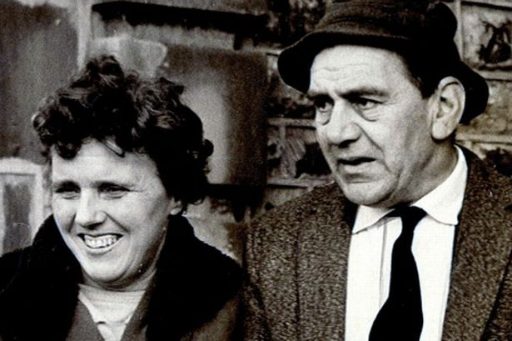
The Story:
Eileen Beasley, a teacher, and Trefor, a miner and union activist, married in 1951. Although they lived in a 90% Welsh-speaking area, when they received their rates (local taxes) demand for their first home from Llanelli Rural District Council, it was written in English, the sole language of the state. They refused to pay anything until they received a bi-lingual version.

Between 1952 and 1960 they were summoned to court at least a dozen times for non-payment of rates but still they would not accept demands in English. The bailiffs visited their house on several occasions to remove household goods to the value of the unpaid rates. By the end of their campaign even the carpet on the floor had been seized - for years, the couple and their two young children lived with only a table, four chairs and their beds.

As part of their campaign, both were elected to the district council in 1955 as
representatives of Plaid Cymru and Eileen went on to be a County Councillor. The Beasleys also used the media to gain support for their campaign, receiving letters of support from around Wales, the UK, Europe and America.

In 1960 the district council finally conceded and produced its first bilingual rates demand notice.

What changes did they want to make?
They wanted to be able to receive official communications from their local council bilingually rather than in English only. This was about Welsh having equal respect and status with English, particularly in areas that were largely Welsh-speaking.

Who did they try to influence?
Primarily their local council, although their struggle also raised the issue of being able to use Welsh in their dealings with the judicial system. The principle was about their right to receive official information in their mother tongue.

What failed, and why?
The Beasley’s struggle was long and hard. It took 8 years of hardship and stress for them to eventually win their case, during which they had to suffer numerous visits from the bailiffs and court summons.

What succeeded, and why?
The Beasleys’ action is credited with kick-starting the Welsh language movement. In 1962 Saunders Lewis a prominent Welsh nationalist and a founder of Plaid Cymru, gave a radio speech entitled Tynged yr iaith (The Fate of the Language) in which he predicted the extinction of the Welsh language unless action was taken; his speech led to the creation of Cymdeithas yr Iaith Gymraeg (the Welsh Language Society) the same year. Saunders Lewis directly praised the actions of Trefor and Eileen Beasley for their campaign for Welsh language tax bills and their method of non-violent civil disobedience has provided both an inspiration and a successful campaign model for language activists in Wales, to the present day.

After milestones such as bi-lingual road signs and the establishment of a Welsh language television channel in 1982, eventually the Welsh Language Act 1993 and the Government of Wales Act 1998 provided that the Welsh and English languages be treated equally in the public sector in Wales.

Follow-up Activities:
- Non-violent methods.
Consider the Beasley’s campaign. What do you think of it? What is remarkable about it?
What non-violent methods did they use?
Why were they successful in the end, in your opinion?

- Values Continuum
Think about an issue you think is really unfair (e.g. racism; gender inequality; the way refugees are treated……) You don’t need to share your issue – just keep it in your head.
Your teacher will draw an imaginary line across the room, with ‘Yes’ at one end ‘No’ at the other and ‘Not sure’ in the middle.
Move to where you stand on the line according to what you think you’d feel comfortable in doing for your chosen issue – e.g.
- Writing a letter to your council / MP / SM
- Signing a petition
- Speaking out publicly
- Going on a demonstration
- Organising a demonstration
- Organising an ongoing campaign
- Speaking to the media
- Getting arrested
- Being fined
- Other??

Discuss what came out of this exercise. Does it depend a bit on what the issue is?

- Imagine….
Imagine you are one of the Beasleys’ young children. How do you think it felt to have possessions taken away and to have to live with the minimum of furniture or home comforts?

Further Info/Links:
Obituaries of Eileen Beasley, including:
- the BBC http://www.bbc.co.uk/news/uk-wales-19240985
- the Guardian https://www.theguardian.com/politics/2012/aug/23/eileen-beasley-obituary
- the Independent http://www.independent.co.uk/news/obituaries/eileen-beasley-welsh-language-campaigner-8190320.html
- Wales Online http://www.walesonline.co.uk/news/wales-news/tributes-paid-welsh-language-activist-2057453

Video clip – interview with Eileen Beasley: https://www.bbc.co.uk/programmes/p016xtyz

What can you do?
Is there an issue you and your friends feel is really unfair / unjust? Discuss and choose your ‘top issue’

What would you be willing to do – and to sacrifice – to fight for justice and equality?

Can you plan an action to stand up for justice and equality on your chosen issue? Remember to talk to teachers and parents about what you’d like to do first……

