Title: Developing the Voice of Young People for Peace
Synopsis/Overview:
After the tragedy and huge losses of WWI, there was an upsurge of activity across Wales for peace and internationalism, largely centred around local branches of the Wales League of Nations Union (WLNU). A number of initiatives came out of that movement, including the founding and development of the Young People’s Message of Peace and Goodwill – an annual peace message from young people in Wales to the young people of the world. The Message has been broadcast every year without fail since 1922 – through wars and economic crises – and will celebrate its centenary in 2022.

When: 1922 until the present day | Where: Across Wales and the world
Background:
Uneasy about the Paris Peace Agreement, David Davies first proposed the idea of the Welsh League of Nations Union from the stage of the Eisteddfod in 1918 – 4 months before the end of WWI. For Davies, who had fought in the trenches, this was the equivalent of a ‘Never Again’ campaign, as illustrated by the following quote: “In the silent moments of our remembrance, we confronted the great phantom host which included the dearest friends of our youth. They would have become restive at the thought of what we – who know now what war means – are now doing to save their dear ones from a similar fate… They say:
“What are you doing about it all? Is it to be nothing… but the laying of wreaths and blowing of last posts?” Many answered his rallying cry, and by the late 1920s, the Welsh League of Nation Union would become one of Wales’ biggest membership organisations, with over 1,000 local community branches and 61,000 members actively campaigning on international issues of the day.

One of those people was the Revd Gwilym Davies, a Baptist minister from the Rhymney Galley who, from 1922, threw himself into organising a ‘Campaign for World Peace’ to involve every man, woman and child in Wales in a ‘mission for internationalism’. Amongst his achievements was the creation of an annual Youth Peace Message. This was first broadcast on 18th May 1922 (that date being chosen as the anniversary of the 1899 Hague Peace Conference) and is still launched annually as the ‘Message of Peace and Goodwill’.

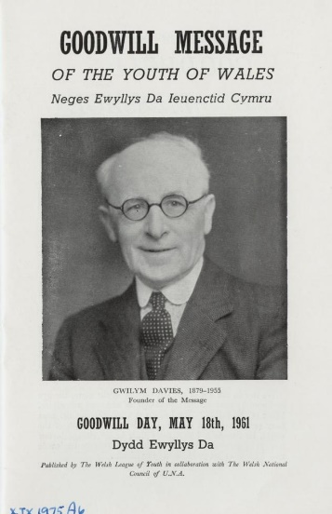
The Story:
In some ways Gwilym Davies seemed an unlikely peacemaker. An unassuming man, he nevertheless threw himself into a number of far-reaching peace campaigns in the 1920s and 30s, including the creation of the Message of Peace and Goodwill, the development of a World Citizenship curriculum, hosting the League of Nations International Peace Conference in Aberystwyth in 1926, and a 1935 Peace Ballot on the European Arms Race. He was an enthusiastic supporter of new technologies: the first Message was sent via Morse Code and from 1924 messages were broadcast on the radio via the BBC World Service.

It is probably for his creation of the Message of Peace and Goodwill that Gwilym Davies is best remembered. From its small beginnings the Message has grown and developed, and it is now broadcast each year by Urdd Gobaith Cymru, Wales’ largest youth movement (another initiative which Gwilym Davies was involved in creating!)

An increasing emphasis has been placed on producing and sharing the Message in a range of different languages, and encouraging responses from young people around the world. In 2021 the Message was produced in 65 languages and shared on social media in 59 countries across the world. Here are just a couple of responses received over the years:
“It is years since we have heard from the Welsh Children. How it grew dark! We should like to hear from you again.” (young people in Germany, 1946)

“We are really happy to know, after so many years of isolation, that you have sent so hearty words of friendship and love.” children in Japan, 1948)
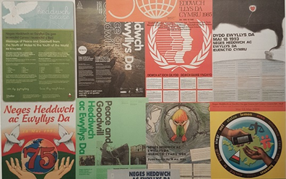
Over the years the theme of the Message has changed, reflecting world events and concerns. Themes have included the atomic bomb, refugees, poverty, war, violence and global warming. The Message is created by a group of young people each year, who decide on the theme, the content of the message, and how they want to deliver it.

The Message is also increasingly linked to wider campaigns for social justice, peace and sustainability. The theme of the 2021 Message was ‘Equality for Women and Girls’ and , in response to the message, the Urdd committed to contributing to tackling poverty in Wales by providing sanitary products for free at their residential centres and events. It was also agreed that the Urdd’s residential centres would become centres where women could visit, rest and feel safe. The theme of the 2022 Message is the Climate Emergency and what young people can do about it, and leading up to the launch of the message on 18th May, schools are encouraged to use an educational pack and support children and young people in getting active for climate justice.

What changes did they want to make?
Gwilym Davies’ original aim was to organise a ‘Campaign for World Peace’ which would involve every man, woman and child in Wales in a ‘mission for internationalism’. He wanted to help create a mass movement that would really change hearts and minds and support ordinary people in campaigning for peace. The Message of Peace and Goodwill has aimed, over the years, to raise the profile of young people’s voice and ensure that it is heard and responded to across the world.

Who did they try to influence?
Gwilym Davies was particularly interested in using technology to get the peace message out to the wider world. He consistently put pressure on the BBC to broadcast the young people’s peace message each year. He wanted to influence ordinary men, women and children through local branches of the Welsh League of Nations Union and also aimed campaigns at educators and churches.
The Message of Peace and Goodwill has increasingly sought to involve children and young people in spreading the message, getting responses to it and taking action on the theme of the message. Recent messages have been broadcast from the Senedd (the Welsh Parliament) and made specific appeals to politicians and world leaders.

What failed, and why?
Although the Welsh League of Nations Union mushroomed in the 1920s and 30s, its activities didn’t prevent the outbreak of a second World War in 1939. The Message of Peace and Goodwill only reached a small audience in its early years.

What succeeded, and why?
Although the League of Nations failed prior to WWII, it was the forerunner for the United Nations which was set up in 1945.
The Wales League of Nations Union was also a basis for post-war organisations in Wales, such as the United Nations Association, the Council for Education in World Citizenship (CEWC Cymru) and UNA Exchange (international exchange programme).
The Message of Peace and Goodwill has gone from strength to strength, and is now taken seriously by politicians, organisations and celebrities. In 2021, the Message was translated into 65 different languages and shared via social media in 59 countries. It’s estimated that the video message reached 5.2 million people across the world.

Follow-up Activities:
- Find out more about Gwilym Davies and / or the Message of Peace and Goodwill:
See the sources of information and further links below.

- Some questions to ask:
What is the significance of the Welsh League of Nations Union and the creation of the Message of Peace and Goodwill for us today?
How can work locally for peace and international understanding have a wider impact – also in times of war?
Gwilym Davies used technology to share the first Message of Peace and Goodwill. What methods can we use today to work for peace, connect with others and put pressure on those in authority?

- Creating your own message of Peace and Goodwill:
Create your own message of peace and goodwill in your school. How would you involve everyone in your school? What would you say? How would you illustrate your message? Who would you share it with?

- Linking with a school internationally:
Create a link with a school in another part of the world – perhaps on another continent or an area which has suffered conflict. Find out what life is like for children and young people there, communicate with them and work to develop joint projects.

Further Info/Links:
Background on Gwilym Davies and the WLNU: Man, Mission and Movement: The Welsh League of Nations Union and the Interwar Peace Campaigns of Gwilym Davies - Welsh Centre for International Affairs (wcia.org.uk)

The history of the Message of Peace and Goodwill: https://www.urdd.cymru/en/peace-and-goodwill/archive-message/

Digitised versions of Messages since 1922 on People’s Collection Wales: https://www.peoplescollection.wales/collections/503567 or here: https://www.sutori.com/en/story/neges-heddwch-ac-ewyllys-da-yr-urdd-urdd-message-of-peace-and-goodwill--WCGHFAzygpgNKesxaC3Ak5b3

An Education Pack on the history and significance of the Message on Hwb: https://hwb.gov.wales/repository/resource/34bea9cb-f9de-4390-8460-22b631bc78c0

A video of the 2019 Message, which illustrates its purpose and importance: https://www.youtube.com/watch?v=-6tLukIV9P4

Information about the 2021 Peace Message and its reach: https://www.urdd.cymru/en/peace-and-goodwill/archive-message/neges-heddwch-ac-ewyllys-da-2021-2/#

Register to get the 2022 pack on the Climate Emergency and what you can do about it:
https://www.urdd.cymru/en/peace-and-goodwill/

What can you do?
- Sign up to be part of this year’s Message of Peace and Goodwill on the Climate Crisis and get active to combat the climate crisis! https://www.urdd.cymru/en/peace-and-goodwill/

- Take part in this year’s Young Peacemakers Awards (https://www.wcia.org.uk/global-learning/individuals/young-peacemakers-award/) – as individuals or groups.

- Find out about the new Welsh Government International Learning Exchange Programme: ‘Taith’ (https://gov.wales/taith-international-learning-exchange-programme)

