Title: Welsh Women’s Peace Petition – working for International Peace
Synopsis/Overview:
This is perhaps the most inspiring story to come out of the WCIA’s Wales for Peace project. It’s the story of a group of women from the Women’s Committee of the Welsh League of Nations Union who felt so passionately about working for international peace that they organised a Wales-wide petition – before the days of the internet and social media – to persuade the President of the USA that his country should join the League of Nations and so prevent a repeat of the horrors of WWI. They collected over 390,000 signatures, and took the petition in a large chest to America, where they presented it to President Coolidge himself and undertook a speaking tour.

When: 1923 - 24 | Where: Wales - America
Background:
Nearly every town and village in Wales was affected by losses sustained in WWI. It is estimated that around 350,000 died in battle. Having witnessed the horrors of war, a group of prominent figures in Wales, including David Davies and the Reverend Gwilym Davies, formed the Welsh League of Nations Union (WLNU), with the aim of work for international peace and cooperation. The WLNU was founded in 1922 to “mobilise the people of Gwalia… every man, woman and child for peace”. The movement grew during the inter-war years, with 1,014 community groups and 61,262 members actively involved in its campaigning activities. Women played a prominent role in promoting peace and organising the WLNU’s activities.

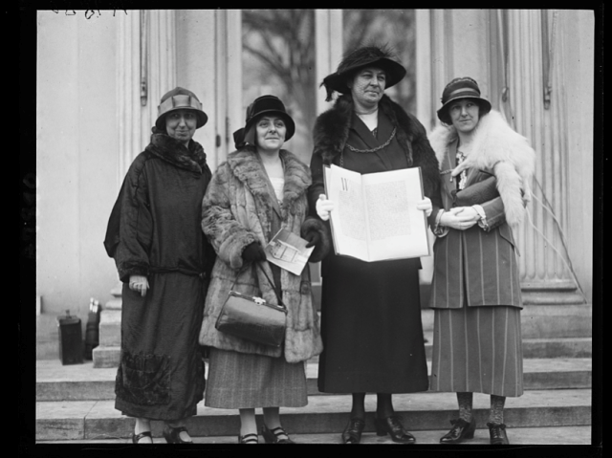
The Story:
In 1923 the WLNU Women’s Committee organised an unprecedented campaign, which led to 390,296 women signing a petition, appealing to the women of America ‘from home to home’ and ‘hearth to hearth’, to join them in a call for ‘LAW NOT WAR’: for the United States to join and lead the new League of Nations. This, they felt, was crucial to avoiding another major war.

How was such a feat organised? The campaign involved almost every household in Wales and meant peace activists going door-to-door, supported through the WLNU’s county and community organisers. The final petition was estimated to be 7 miles in length.

But the story didn’t stop there. The signature sheets were gathered into an oak chest and a delegation, led by WLNU Chair Annie Hughes-Griffiths, travelled from Wales to America in March 1924 for a 2 month ‘Peace Tour’ of the States. The aim of this tour was to build support through American women’s organisations involving over 60 million people.

Annie kept a diary of their travels, offering an incredible insight into the Peace Tour. The 9 American Women’s networks whom the Welsh delegation worked with, joined forces to form the ‘Conference on the Cause and Cure of War‘ as a response to their visit.

Today the chest is housed in the Smithsonian Institute in Washington, but it is hoped that it can return to Wales in 2023 to mark the centenary of this incredible campaign.

What changes did they want to make?
Their overall aim was to secure world peace by putting pressure on the UK and US governments to work together to set up an organisation (the League of Nations) which would work for international peace and cooperation and prevent a repetition of the carnage of WWI.

Who did they try to influence?
Their campaign was a grassroots one, appealing to women from across Wales – many of whom had lost sons, brothers and fathers during WWI. They galvanised women who belonged to peace groups in Wales and America to sign the petition and put pressure on their governments. Their main aim was to influence governments – that of the UK, but principally that of America, as they felt that the US joining the League of Nations was a deciding factor in its success. They personally met with President Coolidge during their American Tour.

What failed, and why?
Ultimately, the League of Nations failed and it didn’t prevent the outbreak of WWII. At the same time, the League formed the basis for the formation of the United Nations in 1945.
What succeeded, and why?
Gathering over 390,000 signatures was an amazing feat, and illustrated both the desire for peace and women’s ability to organise a major campaign to put pressure on politicians and governments. Gathering signatures for petitions is now widely used as a campaigning tool - both on and off-line. This campaign continues to inspire people today, and has led to a new centenary campaign which calls for the strengthening of the UN’s role in international affairs.

Follow-up Activities:
- A diary entry:
Look at Annie’s Diary. What strikes you most about the diary? Do you have a favourite passage or story? Which is it, and why?

Imagine you are a member of Annie’s group. Write your own diary page about something that happened during the journey – for instance meeting President Coolidge or meeting women from one of the American peace groups. How did you feel? How did people react to you, and what did they say? Did you meet people who disagreed with what you were doing? Why – and what did you say to them?

- Drama – door-step conversation:
You are a member of the local WLNU group, and you are helping to go from door to door in your local area gathering signatures for the Women’s Peace Petition.
- Imagine how you would put your case to people who answered the door! What do you say?
- How do people react?
- What might people say who don’t agree with what you are doing? How do you respond?
- Imagine some of the conversations and act them out! How do you feel at the end of the day – Tired? Hopeful? Dispirited? Imagine the conversation with your family at supper.

Further Info/Links:

The Welsh League of Nations Union (WLNU): https://www.wcia.org.uk/wlnu/

‘Inspired by Annie: The story of the 1923 Welsh Women’s Peace Petition to America: https://www.wcia.org.uk/wcia-news/wcia-history/womenspeacepetition/.

‘Alaw Primary School bring 1920s Women’s Peace History to life’, including information and a video made by some of the pupils: https://www.wcia.org.uk/wcia-news/alaw-primary/

What can you do?
Is there something in your school / local community / nationally / internationally you feel particularly strongly about – something that would make life better for people, improve the environment or stop something bad happening……?

Discuss this as a class, perhaps do some research and then brainstorm ideas and vote for which issue you’d like to take action on as a class.
Now think of how you can persuade people to support your campaign – e.g.
- Be clear what you want to achieve. What will look / feel / be different? Who will this affect?
- How will you tell people what you want to achieve and get them excited about supporting you?
- What will you ask them to do (sign a petition / do some fundraising / write letters, etc….)
- Who will do what (you probably have different gifts and skills in your team!)
- Who will you aim to influence?
- Who are your allies (e.g. local politician / mayor / teachers / parents….)
- What methods will you use?
- How will you know you’ve been successful and how will you celebrate success!

Good luck – remember to share photos and videos of your campaign if you can!

