Title: Waldo Williams – Resisting violence through personal action, creativity and humour
Synopsis/Overview:
How do we react when the actions of those who represent us lead us to despair? Waldo Williams, perhaps the greatest Welsh poet of the 20th century and a Quaker, was willing to suffer personally to show his opposition. He reacted with humour in adversity. His poetry stands as an ongoing testament to values of connectedness and relationship.

When: WWII until 1963 | Where: Pembrokeshire, Wales
Background:
Waldo grew up in rural Pembrokeshire, and was deeply influenced by the ideal of a more egalitarian, cooperative society – also by pacifism. He registered as a conscientious objector in WWII and appeared before a tribunal in Carmarthen, even though he didn’t have to do so. (He was then too old for military service, and was temporary headmaster at Puncheston School – a reserved occupation).

The Korean War in the 1950s particularly sickened Waldo: he felt great shame at what he saw as man’s barbarity to man and found it difficult even to face people. He gave up writing poetry, believing that – as Gandhi said – it was action that was needed, not words.

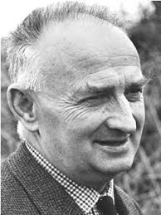
The Story:
As a primary school teacher Waldo had no control over his tax payments as they were taken from his pay packet at source but as a lecturer employed by the Extra Mural Department, University College of Wales, Aberystwyth, he received payment in full and it was his duty then to arrange his income tax payments. Waldo therefore decided to give up his teaching job, and refused to pay the income tax owed from his lecturing post (15%) in protest against spending on warfare and compulsory conscription.
Court bailiffs confiscated some of Waldo’s possessions because of his unpaid tax contributions and he was later jailed on two occasions in the early 1960s for his non-payment. When bailiffs arrived at his home to take his furniture away, one of them was struggling with the carpet, which had been rolled up. Waldo offered him a piece of string from his pocket to tie up the roll. When Waldo’s bicycle was distrained, he ran out with the bicycle pump so that whoever had the bike would also have the means to pump up the tyres. On another occasion Waldo received a summons while he was part way through teaching a course on Welsh literature. The group were very keen on Waldo completing the course so they hid him in an out of the way place until he completed the course and he then gave himself up to the authorities.
Waldo’s friend and fellow poet James Nicolas said of Waldo that his humour and sense of fun assisted him throughout life when he could easily have become embittered. At the same time his protest sprang from deep conviction, as can be seen in his address to the Carmarthen tribunal and in an article he published in 1956 entitled ‘Why I refused to pay income tax’. Waldo eventually suspended his protest when military conscription was abandoned in 1963.

What changes did they want to make?
Like conscientious objectors in WWI, Waldo felt strongly that ultimately violence was wrong, destroying the very fabric of society. His protest was against the use of military force by the State as a way of ‘solving’ problems or conflict.

Who did they try to influence?
In making a speech to the military tribunal in Carmarthen in 1942, Waldo sought to explain the reasons for his pacifism to the authorities. Through his writing, he ultimately reached and influenced a wider audience.

What failed, and why?
We cannot say whether Waldo’s actions had any direct impact, but compulsory military service did come to an end in the UK in 1963. During his lifetime, Waldo suffered for his convictions.

What succeeded, and why?
As a man of great principle and above all as a poet, Waldo continues to influence and inspire. He sums up his conviction in an article he published in Y Faner in 1963:
‘Nothing can set us free except an affinity with other people. Compassion towards the suffering of others can lead us through places that are inexplicable to the reason unless the reason is awakened by the imagination. The only option we have is to face our guilt and transform it into conscience, and transform conscience into responsibility. Then our responsibility will become a vision. But this is very difficult for us.’

The right to conscientiously object to fighting in wars has now been established in International Law (Article 18 of the United Nations Declaration of Human Rights), although conscientious objection is not allowed in several countries (e.g. Finland, Turkey and Israel) and is contested in times of war.

Follow-up Activities:

- Find out about Conscientious Objectors in Wales during WWII.
How were they treated?
How did attitudes to conscientious objection change between WWI and WWII. Why do you think this happened?
Two further examples of Conscientious Objectors during WWII are Dyfnallt Morgan and Mervyn Turner. What else do these stories tell you about conscientious objectors and the choices they faced?

- Defending your opinions:
What do you feel really strongly about? Write a statement expressing your views.
Imagine you had to defend your views at a tribunal, like Waldo did. What would you say? What supporting evidence could you use?

- Drama – Non-violent techniques:
Act out the situation of Waldo, the bailiffs and the carpet, or the incident with the bicycle pump.
How do you think Waldo felt really? What about the bailiffs? What effect do you think Waldo’s actions had on the?
In these incidents, Waldo used humour, kindness and surprise. What other techniques do you think could be useful if you wanted to react to a situation non-violently?

- Creative writing:
Look at Waldo’s poem ‘The Peacemakers’ (‘Y Tangnefeddwyr’). Waldo wrote this poem as he saw the bombed city of Swansea burning on the horizon. What are the main ideas in the poem, and what does this tell us about Waldo’s pacifism?
Write a poem expressing your thoughts and desires about peace.
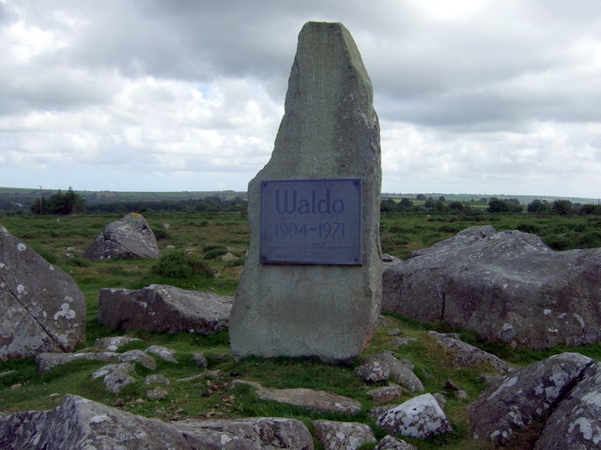
- Remembering Peacemakers:
There are lots of memorials in our towns and villages to remember those who have died in wars. There’s a memorial stone to Waldo in the Preseli Mountains, Pembrokeshire. How do you think we should remember the peacemakers?
Design a work of art or memorial to remember those who have worked for peace.

- Working with others for change:
What does civil disobedience mean? Waldo refused to pay a proportion of his taxes. What other forms can civil disobedience take? Do you think it’s effective? Can you think of examples where people have worked together to make a stand against injustice (e.g. going on strike; not obeying unjust laws; Civil Rights movement in the US; Black Lives Matter in the UK)

Further Info/Links:

More information about Waldo’s life can be found on Wikipedia here.
See also his biography here.

Waldo, the Pacifist: Cymdeithas Waldo: http://www.waldowilliams.com/?page_id=97&lang=en

Video of Waldo’s poem ‘Y Tangnefeddwyr’ (‘The Peacemakers’) set to music, with English. Waldo wrote the poem as he saw bombed Swansea burning on the horizon during WWII: https://www.youtube.com/watch?v=H1lt_Bfr8Dg

The story of Waldo on the bilingual DVD ‘Voices of Conscience’, produced by Quakers in South Wales: http://www.breakingbarriers.org.uk/voices-of-conscience/

Waldo’s speech to the Tribunal in Carmarthen can be found on pages 141-2 of ‘The Story of Waldo Williams: Poet of Peace’ by Alan Llwyd (Barddas Publications, 2010).

Waldo’s poetry is available bilingually in the collection ‘The Peacemakers’ (Gwasg Gomer) with translations by Tony Conran
Some of Waldo’s poetry – translated:
http://www.waldowilliams.com/?page_id=327&lang=en

What can you do?
- Make an exhibition:
Not many people know about Waldo’s poetry and life. What about running an assembly on him in school or creating an exhibition in your school or local library?

- Take action:
Think of an issue that is of concern to you (individually / as a group).
- Why is this an issue?
- What would you like to change? (in your school / locally / nationally)
- Who do you need to address your campaign to?
- What methods can you use? (May this include creativity, humour and surprise as Waldo used them?)
- What will you do, when and how? Is there anyone you need to ask permission from (e.g. your teacher, parents….)?
- How will you know if you have succeeded? (What do you want to achieve)?

Go! Remember to take photos of your Action and share with others!

