Title: No Death Drones
Synopsis/Overview:
5 Peace activists painted large slogans on the runway of Llanbedr Airfield where there has been a proposal to test military drones using RAF planes from Valley, Anglesey.
When: 13th June, 2014 | Where: Llanbedr Airfield, Harlech
Background:
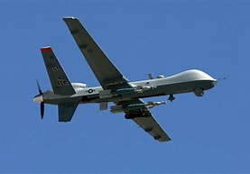
There has been an increase in the use of militarised drones in warfare in recent years. The defence for their use is that they can ‘take out’ terrorists without having to deploy ground troops. They are therefore seen as safer and cheaper than other military methods.

There are many problems with these arguments. A recent study has shown that the majority of those killed by drones are actually innocent civilians rather than ‘terrorists’. This causes an increase in animosity towards the attacking country (e.g. the US) amongst the local population, the opposite of what is intended. Those who are killed aren’t officially charged of any crime and don’t have an opportunity to defend themselves in court – hardly methods that should be being used by democracies. Children living in areas where there are drone strikes are traumatised by the buzzing of the drones, and are unable to play normally. Those ‘piloting’ the drones suffer PTSD at higher rates than actual pilots. Moreover, if it is legitimate for – say – the US or the UK to use drones for military purposes, what is to prevent the same technology being developed by our ‘enemies’?

All the Peace Activists concerned in this action are members of Cymdeithas y Cymod / the Fellowship of Reconciliation in Wales, an international organisation that has campaigned consistently against war since 1914. Cymdeithas y Cymod is opposed to the use of drones for military purposes and has campaigned against the development and testing of these in West Wales.

There was increasing concern, leading up to this protest, that drones would also be tested at Llanbedr Airfield near Harlech. This would have represented a considerable expansion of military activity in the area. Because of this concern, a number of non-violent actions were taken, including:
- A public meeting in Porthmadog with experts from the Drone Campaign Network and with local people from Aberporth to discuss the planned use of Llanbedr for Military drones;
- Distribution of leaflets sharing information about the use of drones and their impact in other countries (e.g. Afghanistan, Syria). These leaflets were distributed from door to door in Harlech, Llanbedr, Dyffryn Ardudwy and on the streets in Porthmadog and Pwllheli;
- A vigil at the main gate of Llanbedr Airfield where photographs of drone victims were tied onto the fence; and
- Media (radio and newspaper) coverage for all of the above.

The Story:
Having tried every other route, and on the understanding that the drones’ arrival was imminent a small group decided to take direct action in order to gain wider public support and awareness. They entered the airfield, painted Dim Adar Angau / No Death Drones on the runway, then gave themselves up to the police.
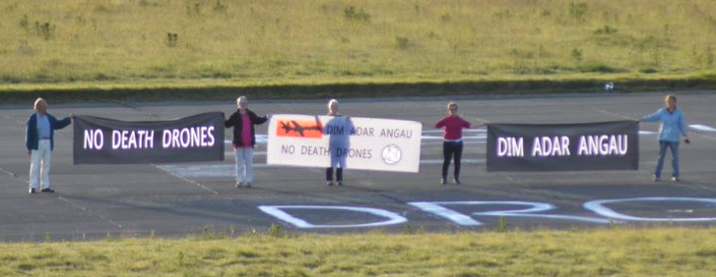
What changes did they want to make?
They wanted to bring the attention of the media, local people and the wider public to what was happening at Llanbedr and to raise awareness of the consequences of using armed drones.

Who did they try to influence?
The local community and wider public. The airfield authorities at Llanbedr and RAF Valley to prevent the expansion of military operations to Llanbedr.
What failed, and why?
Llanbedr Airfield pressed charges and eventually brought 4 of the 5 protesters to court for criminal damage. This could be seen as a ‘failure’, although it was also an opportunity for the protestors to publicise their case further.

The 4 were found guilty and each ordered to pay the costs of cleaning the paintwork and court costs amounting to £565 each. They were not actually fined for their actions. In the event, Cymdeithas y Cymod members and supporters raised more than enough money to cover the costs.

Although there has been no further expansion of military activity at Llanbedr, this could still happen, and members of Cymdeithas y Cymod are keeping a ‘watching brief’.

What succeeded, and why?
The protestors were successful in raising awareness of their opposition to the use of drones in warfare. Their action was reported in the press and on television. Supporters from the National Eisteddfod in Meifod attended the first hearing in Dolgellau Magistrates Court which took place on Hiroshima Day in August 2015. Cymdeithas y Cymod’s annual Hiroshima service in the Cytun tent on the Eisteddfod field also included prayers for the court case.

At the second hearing at Caernarfon Magistrates Court in September 2015 they had an opportunity to explain the reasons for their action - to stop an 'offence against mankind'. Drones make the world a more dangerous place to live in, and people should see the connection between these despicable arms and the plight of refugees.

Acting as a witness Jill Evans, MEP, said that she had visited Gaza and had been an eye witness to the damage that drones can cause. 530 MEPs had called for robotic planes to be banned, she said. As drone technology is developing faster than the legal system, it is a grey area.

As a result of the hearing, some of the protestors fears were confirmed. Jason Coleman who works at Llanbedr Airfield gave evidence that there is a connection between Llanbedr Airfield and Qinetiq (a company that specialises in defence technology).

One of the defendants, Angharad Tomos hailed the verdict as a victory. “If we have drawn people's attention to the dangers of drones, then our action was a success”.

Follow-up Activities:
- ‘Fly Kites not Drones’:
Look at this exciting pack (link below) and choose some of the activities. Learn about Aymel in Afghanistan, make a kite and discuss some of the ethical issues about the use of drones.

- Standing up for your beliefs:
The protestors in this story felt so strongly about the use of armed drones and the threat they pose to innocent life that they were prepared to go to court to state their case. Some questions to discuss:
- What actions did they take before painting the slogan on the airfield?
- How does it feel when you are worried or afraid and no-one is listening to you?
- How do you think the protestors felt?
- What actions do you think you would be prepared to take to stand up for your beliefs?

- Do some research on the use of Armed Drones, then hold a class debate:
The topic could be ‘The use of armed drones should be banned in international law.’
You can use Workshops 5 of ‘Fly Kites not Drones’ to help you to prepare for your debate.

Further Info/Links:
Some facts about armed drones – adapted for children and young people: http://www.flykitesnotdrones.org/drones

The case against armed drones: https://truthout.org/articles/the-case-and-the-movement-against-armed-drones/

‘Fly Kites not Drones’ an educational resource for primary and secondary pupils, including assemblies and interactive and creative activities to support young people in learning, developing empathy and thinking about the moral and ethical issues: http://www.flykitesnotdrones.org/resources.

Film ‘Dim Adar Angau / No Killer Drones’ https://vimeo.com/208001866

What can you do?
- Organise an exhibition in your school or local community about the use of armed drones. Is this something that concerns you? Why?

- Write a letter to your local MP expressing your views about armed drones. What would you like to happen?

