Title: The Role of the Arts in Non-violent Action

Introduction to lessons

This series of lessons introduces learners to the role that the arts can play in protest using two different case studies as examples. The English Disco Lovers was created by Quaker artist, Chris Alton in 2012 as a counter-English Defence League group aiming to reclaim the EDL acronym. In the Singing Revolution the Baltic states of Lithuania, Latvia and Estonia won freedom from the Soviet Union through a series of singing protests including a 600km human chain through the three areas.

The lessons include song analysis, drama and art as well as P4C enquiries.

Curriculum links: RSHE, Citizenship, History, Music, Art and design, Expressive Arts, English, Drama, Dance/PE, Religious Education

English National Curriculum for Citizenship links: KS2 Knowledge, skills and understanding: ‘1a talk and write about their opinions, and explain their views, on issues that affect themselves and society’; ‘2a to research, discuss and debate topical issues, problems and events’; ‘2c to realise the consequences of anti-social and aggressive behaviours, such as bullying and racism, on individuals and communities’; ‘2e to reflect on spiritual, moral, social and cultural issues, using imagination to understand other people’s experiences’; ‘2g what democracy is, and about the basic institutions that support it locally and nationally’; ‘2h to recognise the role of voluntary, community and pressure groups’; ‘2i to appreciate the range of national, regional, religious and ethnic identities in the UK’; ‘2k to explore how the media present information’
KS3 ‘Pupils should use and apply their knowledge and understanding while developing skills to research and interrogate evidence, debate and evaluate viewpoints, present reasoned arguments and take informed action’; ‘Pupils should be taught about…the roles played by public institutions and voluntary groups in society, and the ways in which citizens work together to improve their communities, including opportunities to participate in school-based activities’.

Learning outcome:
- To understand the powerful role that the arts can play in non-violent movements for change.
- To analyse the purpose and strategies of the protest movements.

Concepts:
Protest
Belonging
Racism
Freedom
Democracy

Key vocabulary:
Music genre
Meme
Logo

Resources:
Amplified 70s disco music. Disco ball, disco lights
PowerPoint slides of photographs from 1970s
Song clips from different genres/decades (not provided)
PowerPoint slides of photographs from 60s, 70s, 80s, and 90s
Links to Protest song lyrics from different countries/periods in history
Resource Sheet 32: Song Analysis Sheet
Picture of social media logos on PowerPoint
PowerPoint Photos of Coats of arms and protest marches/dances of each group
PowerPoint of background of EDLs. Aim of English Disco Lovers and why disco.
PowerPoint with link to film
Resource sheet 33: Singing Revolution Freeze Frame story for groups
PowerPoint instructions for groups
Resource sheet 34: Movement for Change checklist
Resource Sheet 17: P4C Steps
Resource Sheet 35: Singing Revolution summary for teachers

https://www.youtube.com/watch?v=4njksFKyycY trailer of film about singing revolution 2.39 mins
https://www.youtube.com/watch?v=Re1Lj3dH0fc 10 min film history of singing revolution
https://www.youtube.com/watch?v=CNjBwIsT8sU 5 min film about Estonian singing tradition

a. Starter activity

Activity Lesson 1 Introducing Music | Time
1. Turn the classroom into a 70s disco with lights and music for learners to experience as they enter the room.  - Discussion: Where have you heard this music before? Do you like this type of music? How does it make you feel?  - Introduce specific genre of Disco with pictures on PowerPoint from the 70s showing fashion, culture etc. Ask learners for words which reflect the music (e.g. fun, dance, freedom etc.) | 10 mins.

b. Main activities

Activity Lesson 1 | Time
1. In groups learners list different genres of music that they know (e.g. Hip Hop, jazz, R & B, folk, soul, electronic, bhangra, grime etc.)  https://en.wikipedia.org/wiki/Music_of_the_United_Kingdom | 10 mins.
2. Listen to clips of different genres of songs with pictures of fashion/culture etc. of the time (pictures on PowerPoint from 60s, 70s, 80s, 90s)  - What are songs for? Brainstorm as whole class (dancing, religious celebration/practice, expressing feelings, expressing ideas, protesting, enjoyment and relaxation, belonging.) | 10 mins.
3. What role might song music play in non-violent protest?  - Look at selection of lyrics from protest songs from different countries e.g. Imagine (John Lennon), Where is the Love (Black Eyed Peas) We Shall Overcome (Joan Baez) What’s Going On (Marvin Gaye) https://en.wikipedia.org/wiki/Protest_song and analyse them using the Song Analysis Sheet (RS32). | 30 mins.

Activity Lesson 2 | Time
Conduct a P4C Enquiry using protest song/s as the stimulus  Follow steps 3-10 | 60 mins.

Activity Lesson 3: English Disco Lovers | Time
1. What is social media used for?  - Present social media logos (on PowerPoint).  - Which do you know? What are they used for? Who uses them? What influence do they have? | 10 mins.
2. Compare photos from EDL (English Defence League) and EDL (English Disco Lovers) – coat of arms, protest marches/ dances (PowerPoint)  - Present background to both EDLs – make link with history of racism work in BBB lesson (PowerPoint).  - How did English Disco Lovers use social media?  https://qz.com/1059410/disco-isnt-dead-its-being-used-as-a-secret-weapon-for-disarming-british-neo-nazis/  Newspaper article about the protest. | 20 mins.
3. Summary of English Disco Lovers (film embedded into PowerPoint)  https://vimeo.com/361873590?fbclid=IwAR3GToUyw  TTOHZQMmdUAao83D8zf4PiuSQddFmm0eAOk8cMvH9UwUkm15nc  - Show memes that English Disco Lovers created and how it reached top of Google when searched. (PowerPoint)  - Illustrate a meme or create your own meme for English Disco Lovers. | 30 mins.

Activity Lesson 4 (optional) | Time
Conduct a P4C Enquiry using English Disco Lovers as the stimulus.  Follow steps 3-10. | 60 mins.

Activity Lesson 5: The Singing Revolution | Time
1. Estonian song to introduce – learn a verse together (or just listen) or watch introduction to Singing Revolution:  https://www.youtube.com/watch?v=aCDsPbUORtc | 10 mins.
2. Give each group part of the Singing Revolution story to act out/retell (RS33). Give them time to make/find props to bring the story alive. Take photos of freeze frames. Print as a storyboard for learners to add descriptions to as a follow up to this lesson. | 30 mins.

c. Reflection / evaluation

1. Summarise the Singing Revolution and English Disco Lovers using the Movement for Change Checklist (RS34) as a whole class or in groups and discuss the role of music and creativity in non-violent movements for change.

2. What questions now arise for the group from studying the two case studies on the role of the arts? Generate questions which might be able to be used for a P4C enquiry (which can then take place in this lesson or follow-up lesson).

d. Suggested follow-up activities

Groups compose own protest song lyrics set to a well-known tune and perform.
P4C enquiry based on questions generated in the reflection.

Teachers’ evaluations of lessons

English Disco Lovers lesson was great, my class absolutely loved it - probably one of the best P4C sessions I've done. We started by looking at the images of 1970’s – this took quite a while and was a good discussion, as many did not know what a record player was for example so we discussed this a bit more in depth than I had thought. We listened to ‘I will survive – Gloria Gaynor’ and ‘We are Family – Sister Sledge’ and thought about how it made us feel etc.
I then summarised what the EDL was, and collected the children’s first thoughts.
We then looked at the history of Jazz music (next time, I would use videos to show what this was, possible footage from Paris during WW2 occupation?), and then looked at Steve Dahl in Chicago (again, I would use photographs of this as quite an abstract concept – would bring in a record from home to show what they are).
I then gave the children some example ‘Memes’ from the English Disco Lovers, and their task was to create their own. I was doubtful how successful these would be because of the children not having a great knowledge of Disco music, but they were great and really successful with the slogans (much better than what I had come up with as examples). We then created P4C questions and voted and had an enquiry – our chosen question was ‘Does doing something wrong and blaming someone else for it make it right?’ We ended the session and the day by leaving the classroom to disco songs of their choice.

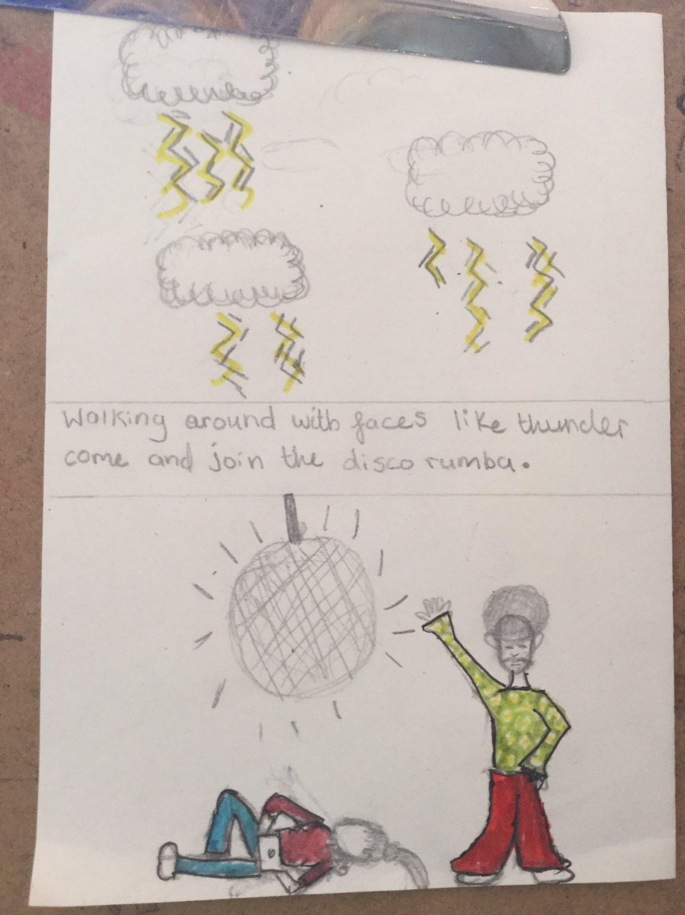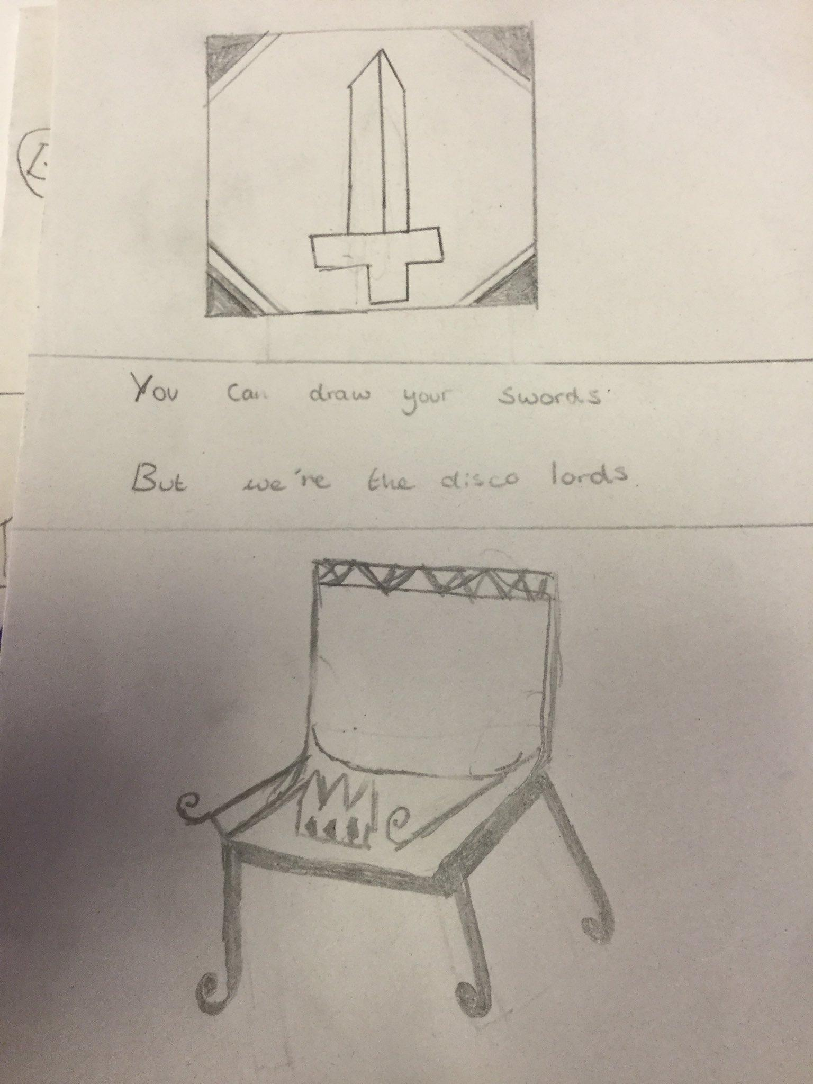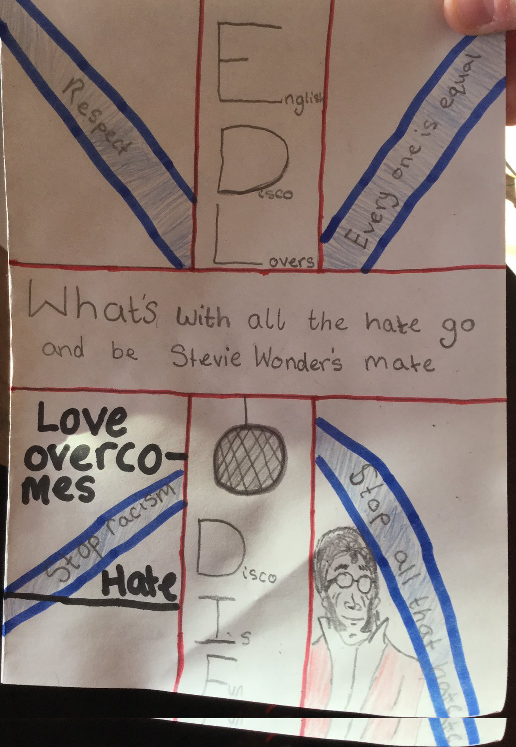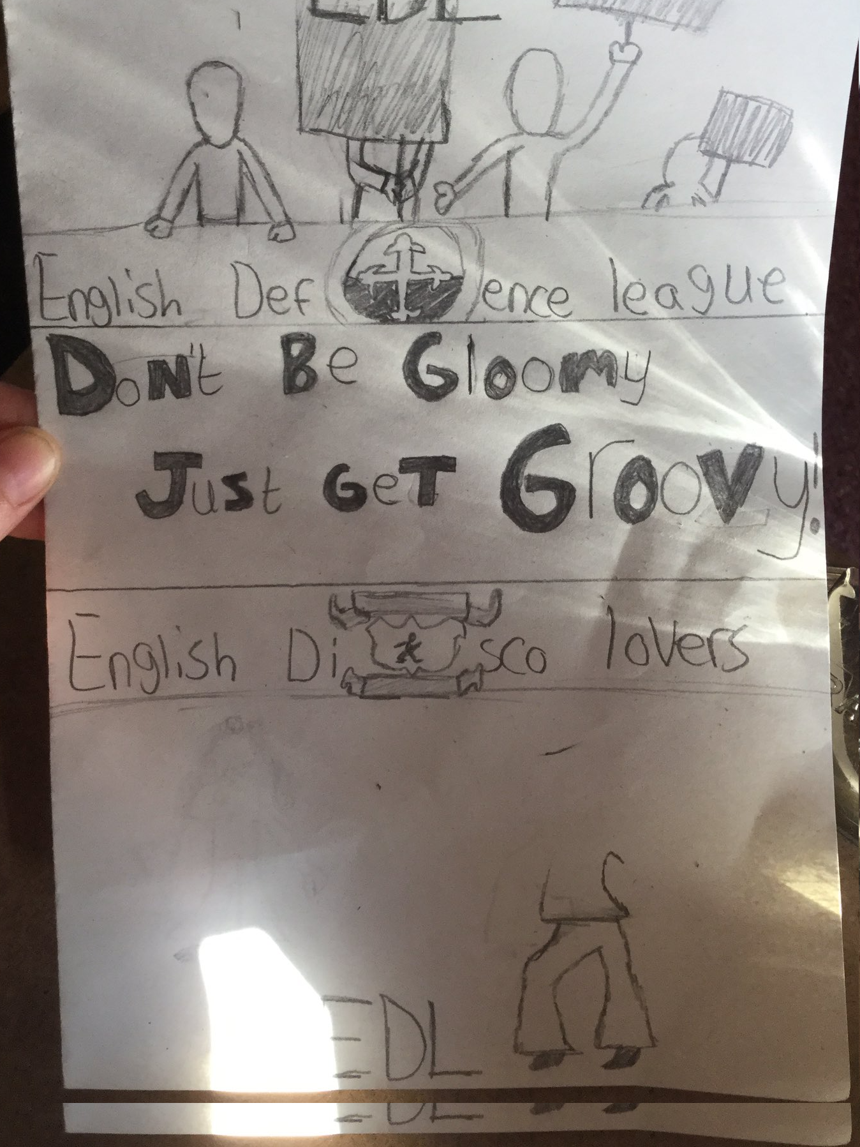

The pupils enjoyed this lesson. The starter was engaging and caught the attention of all pupils. Most pupils in the class had songs they could relate to culturally. It was interesting to see how some were knowledgeable in the history of certain genres and they could share their experiences and knowledge. We talked about Marvin Gaye, Bob Marley and other artists who performed songs of freedom and current artists who sing songs of protest against current injustices. We spent more time on genres and artists and listening to many songs just to bring those pupils who had no capital in music up to speed. The song analysis worksheet was very useful. I would give pupils more time to write the lyrics of their songs of protest on current issues of their choice. Pupils had much to say about the English Defence League. They were quick to identify the strategies of English Disco Lovers.

