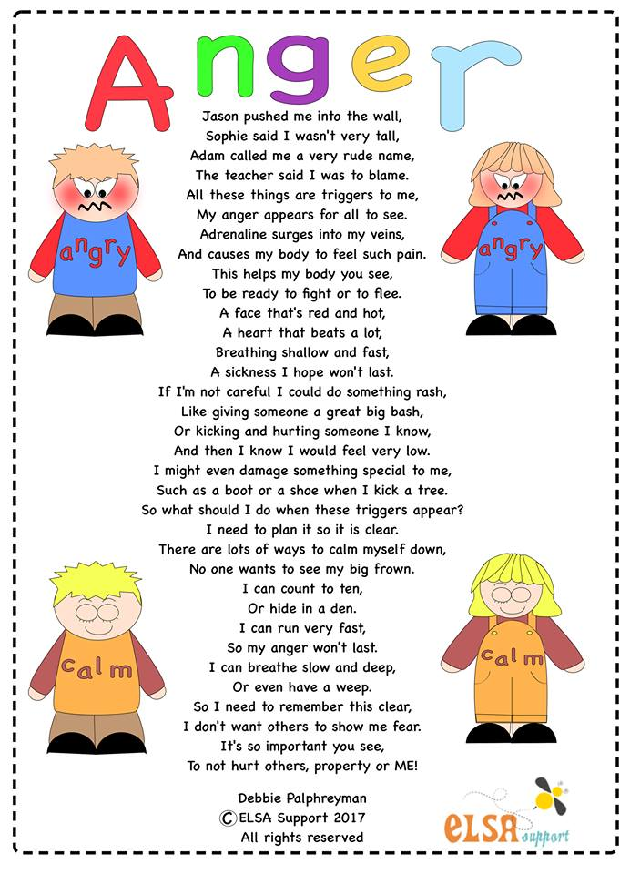

What questions could we ask that would help a child with their anger?
- What is the poem about? Anger
- Have you ever felt angry? Yes everyone does sometimes
- What is anger? An emotion
- What does an angry face look like? Can you show me?
- What other words mean the same as angry? Mad, furious, seething, cross etc.
- What triggers does the person in the poem have? What are your triggers? Being pushed, called names, being blamed, being teased
- What is adrenaline? A chemical that is released in our bodies when we are angry
- What affects did the adrenaline have on the person in the poem’s body? A red and hot face, fast heart beat, fast breathing and feeling sick
- How does being angry affect your body?
- What sort of things does this person do when they are angry? Bash someone, kick and hurt, damage something special
- What sort of things do you do when you are angry?
- How do you feel afterwards when you have calmed down?
- What is the person going to plan? Calming strategies, ways to cool off
- What could you plan if you get angry?
- What calming strategies does the person in the poem use? Count to ten, hide in a den, run fast, breathe slowly or have a cry.
- What could you try to do?
- What is it important not to do when you are angry? Hurt others, property and yourself
- How could you let your anger out safely? Any safe way such as screaming into a pillow or punching a pillow

https://www.elsa-support.co.uk/anger-poem-children-questions/

With thanks to Debbie Palfreyman www.elsa-support.co.uk (used with permission).

