BEFORE: Kent Road, Sheffield

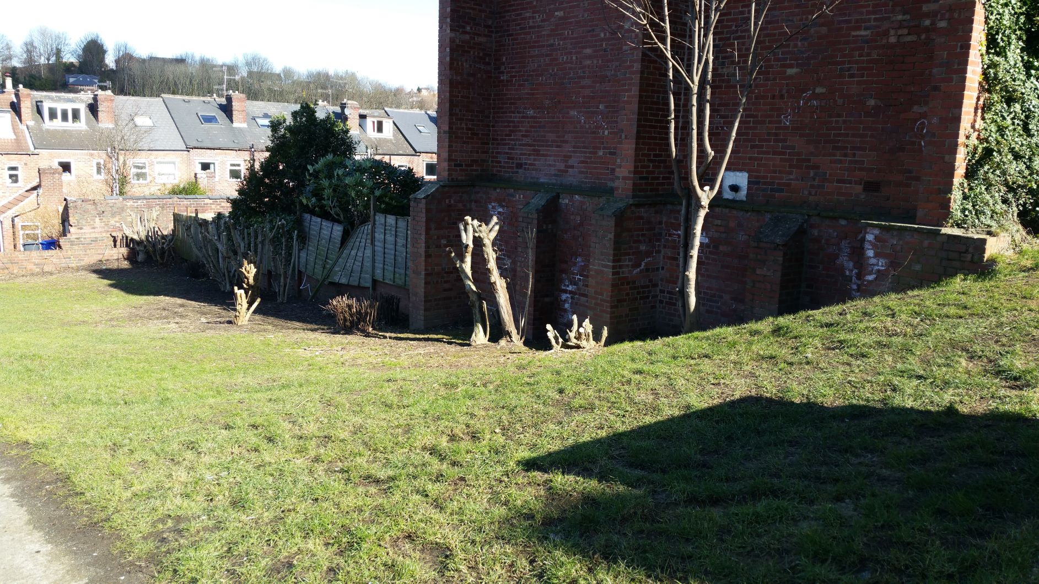

AFTER: Kent Road, Sheffield
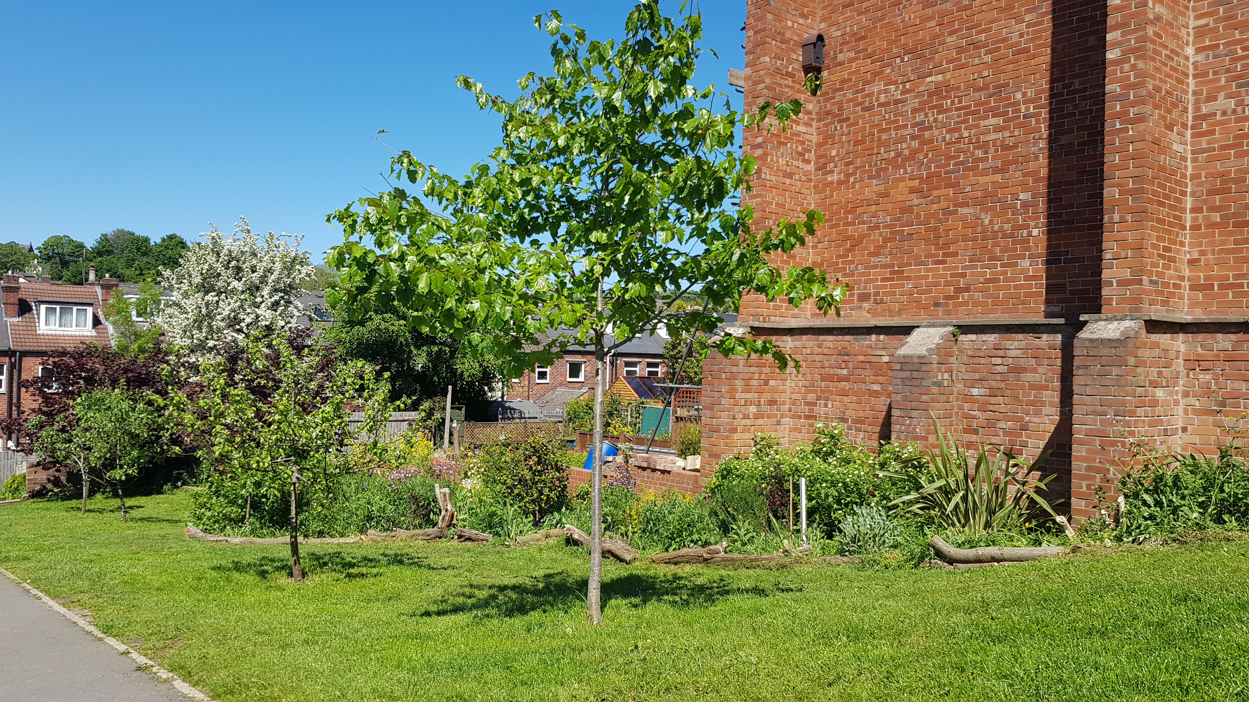

BEFORE: Brooklyn Road, Sheffield

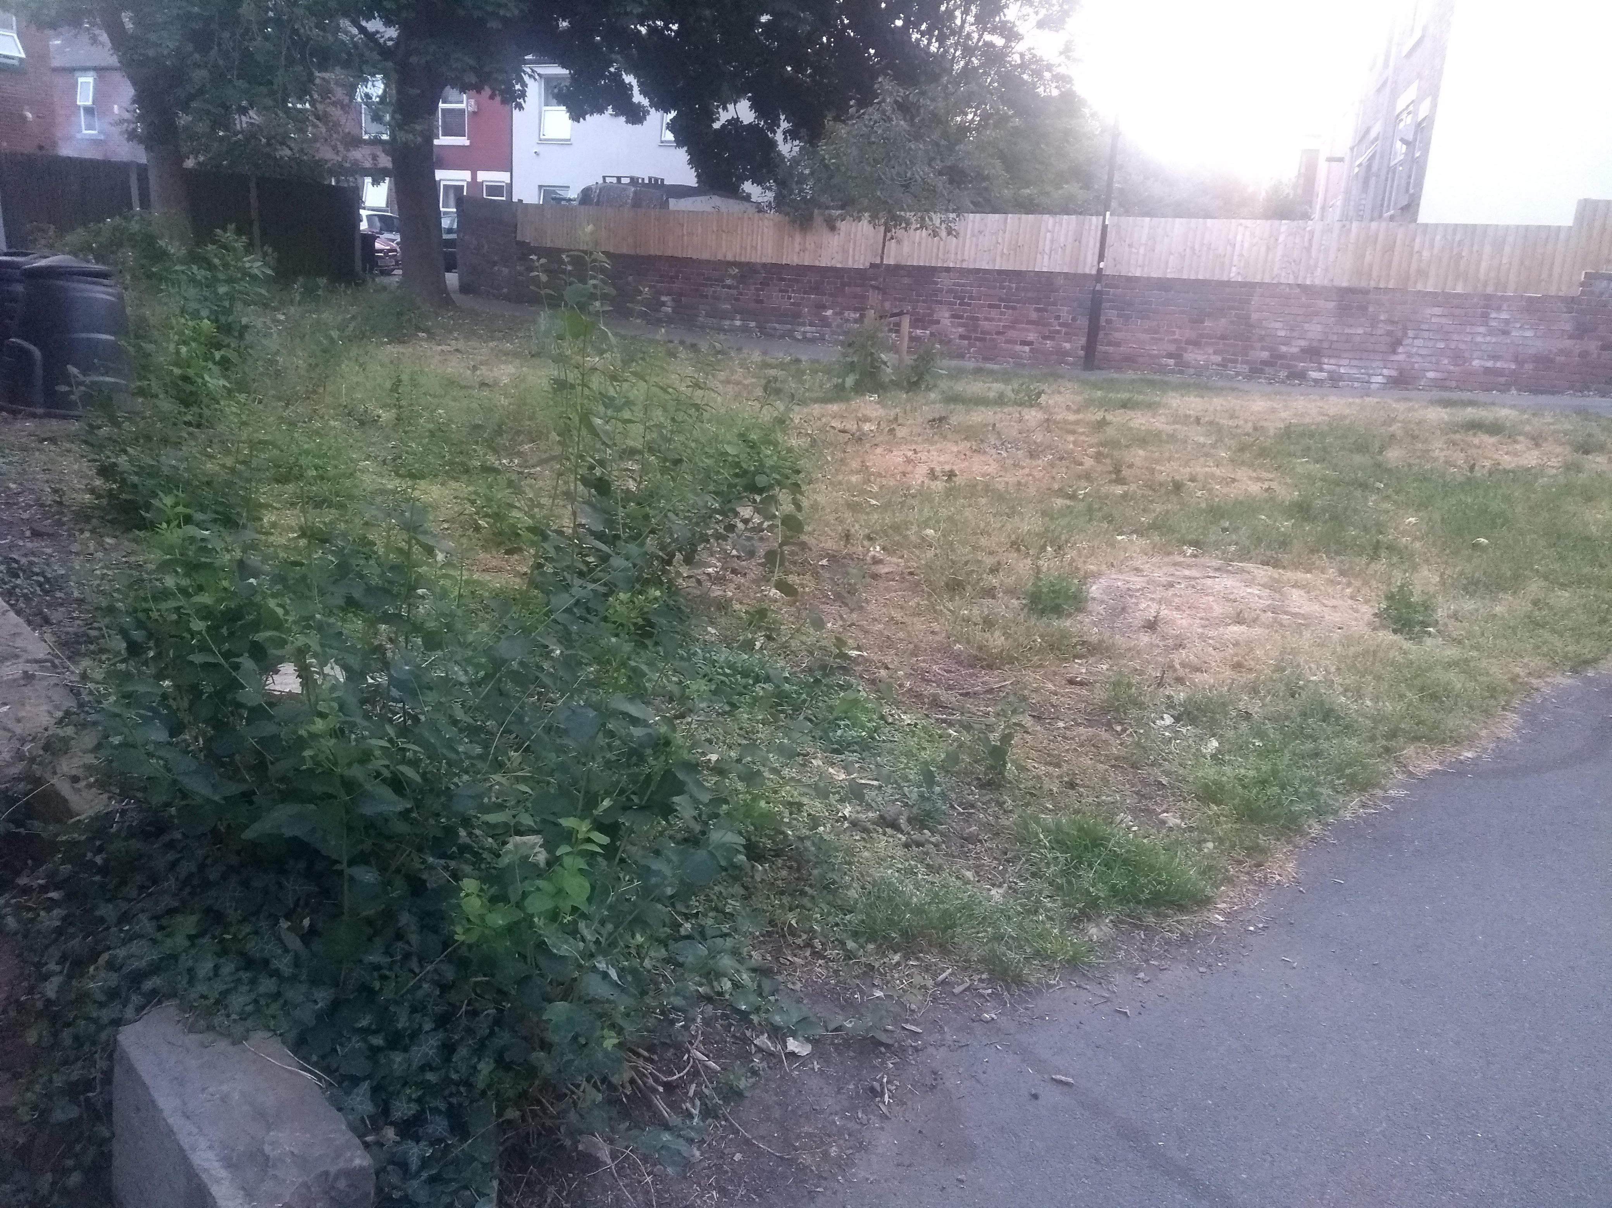

AFTER: Brooklyn Road, Sheffield
