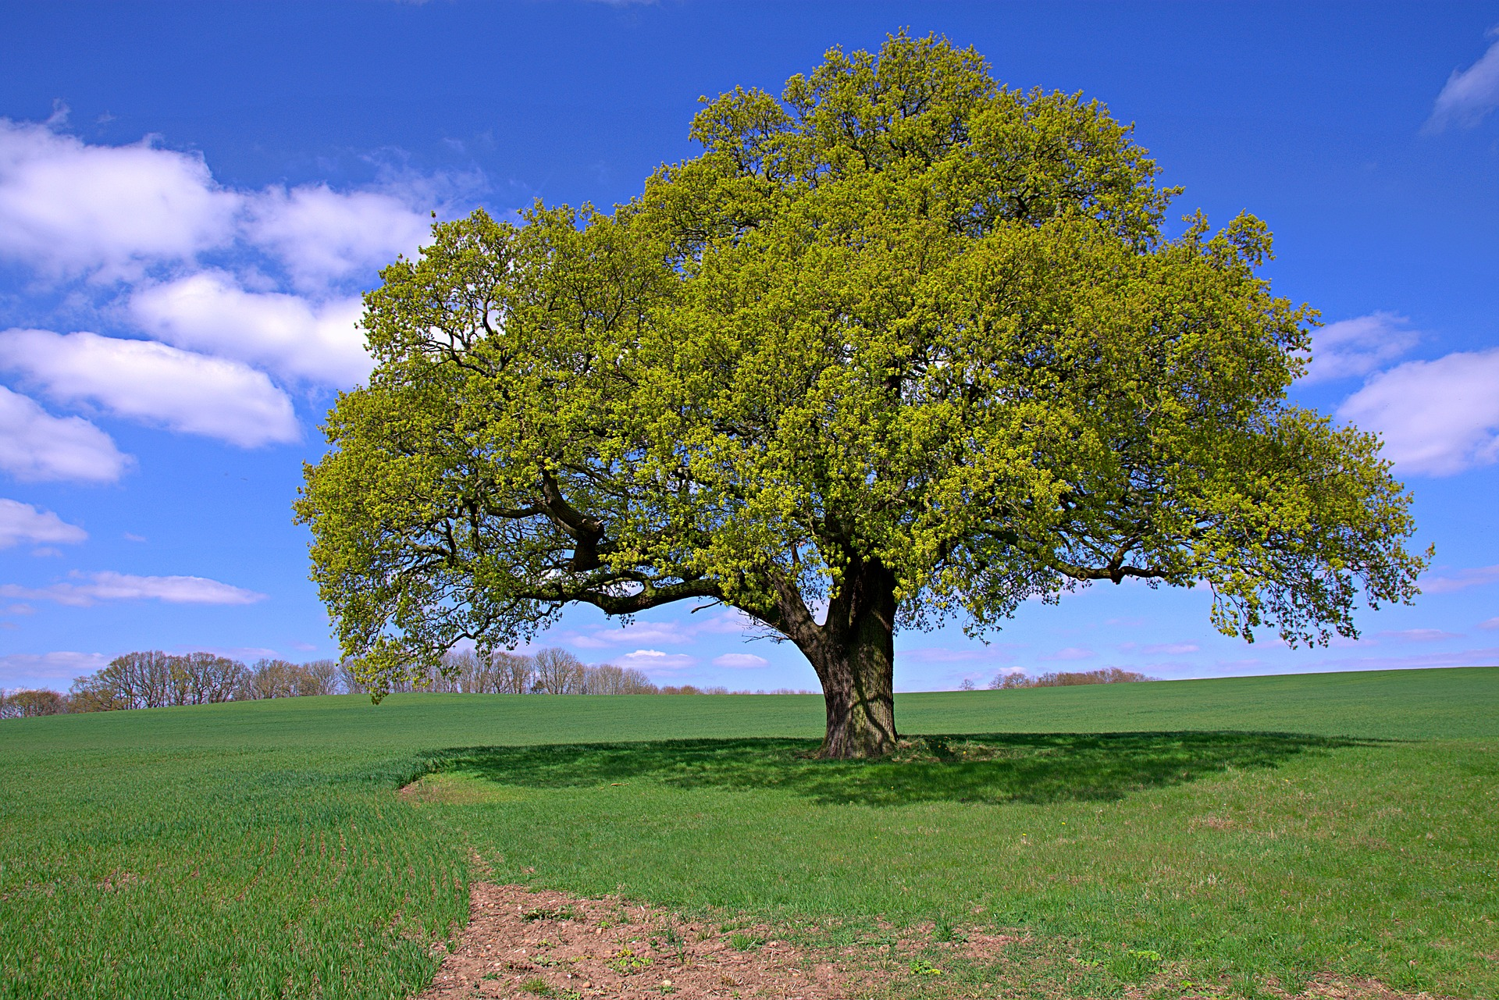

https://pixabay.com/photos/lone-tree-field-wheat-tree-4127920/
Attribution: Nottmpictures/ Pixabay License

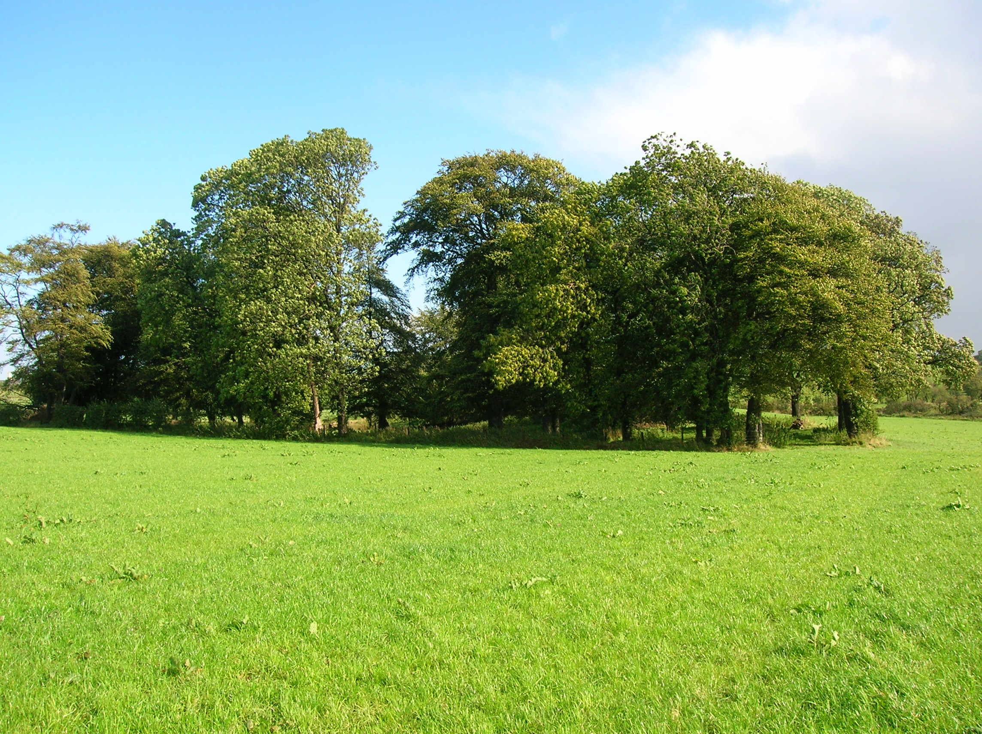

https://commons.wikimedia.org/wiki/File:Old_woodland_copse_at_Mossend_Farm_ruins.JPG Rosser1954 Roger Griffith [Public domain]
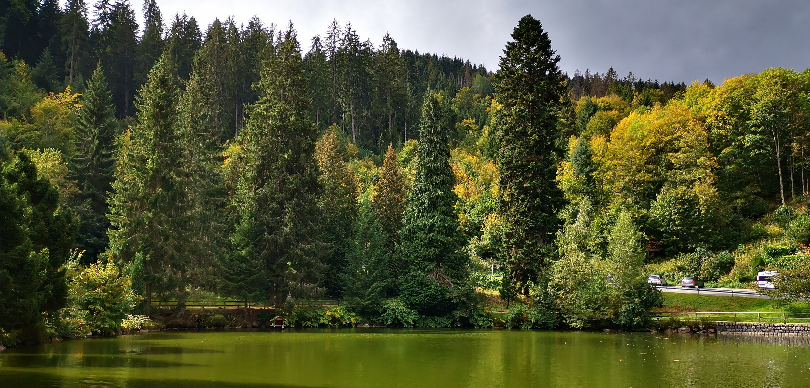

https://pixabay.com/photos/black-forest-triberg-waters-forest-4572312/
Attribution: roemi62/ black forest/ Pixabay License

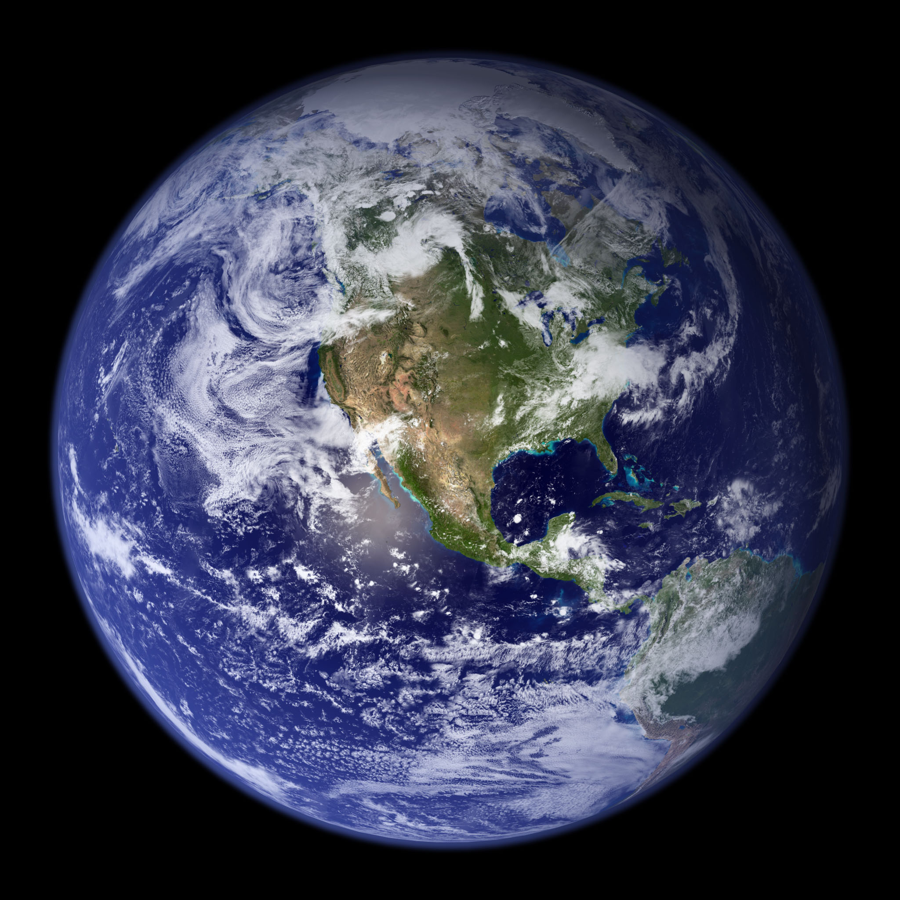
https://www.flickr.com/photos/wwworks/2222523486
Attribution: woodleywonderworks/ Blue Marble(Planet Earth)/ CC BY 2.0

